Notes used in the Message

www.SpokenWordChurch.com
18-1114 – The Revelation Of Jesus Christ Which God Gave Unto You – Luis Urrego
Revelation 1:1-6
» 1 † ¶ The Revelation of Jesus Christ, which God gave unto him, to shew unto his servants things which must shortly come to pass; and he sent and signified it by his angel unto his servant John:
» 2 † Who bare record of the word of God, and of the testimony of Jesus Christ, and of all things that he saw.
» 3 † ¶ Blessed is he that readeth, and they that hear the words of this prophecy, and keep those things which are written therein: for the time is at hand.
» 4 † John to the seven churches which are in Asia: Grace be unto you, and peace, from him which is, and which was, and which is to come; and from the seven Spirits which are before his throne;
» 5 † And from Jesus Christ, who is the faithful witness, and the first begotten of the dead, and the prince of the kings of the earth. Unto him that loved us, and washed us from our sins in his own blood,
» 6 † And hath made us kings and priests unto God and his Father; to him be glory and dominion for ever and ever. Amen.

1) 60-1204M THE.REVELATION.OF.JESUS.CHRIST_ JEFFERSONVILLE.IN ROJC 9-67 SUNDAY_
« 102 † And notice, it also is the consummation of the Scriptures, the complete consummation. And it's geographically placed at the right place, at the end of the Bible. The Revelation of the whole thing placed back here with a blessing to who reads It and hears It, with a curse to them that'll add to or take away. It's the complete canon, oh, the absolute. Nothing can be added to It. And when a man tries to take anything away from It, or add anything to It, God said He'd take the same part out of the Book of Life. See? He would take his part from the Book, if he added to It.
Therefore, when we see the manifold Revelation of our Lord, who He is, what He is, if any person shall add something to That or take anything away from It, it's a false prophecy. Many have tried to say they had something later than That. But That is the complete Revelation of the Lord Jesus in His church age and in His Day, a Revelation of our Lord.
Now--now, unveiling, the Greek word, something that's been hid, unreve-... "revealing" Christ.

2) « 13-4 † THE.REVELATION.OF.JESUS.CHRIST - CHURCH.AGE.BOOK CPT.1
The importance of revelation by the Spirit to a true believer can never be over emphasized. Revelation means more to you than perhaps you realize. Now I am not talking about this Book of Revelation and you. I am talking about ALL revelation. It is tremendously important to the church. Do you remember in Matthew 16 where Jesus asked the disciples this question,
"Whom do men say that I the Son of Man am?
And they said, Some say that Thou art John the Baptist: some, Elias; and others, Jeremias, or one of the prophets.
He saith unto them, But whom say ye that I am?
And Simon Peter answered and said, Thou art the Christ, the Son of the living God.
And Jesus answered and said unto him, Blessed art thou, Simon Barjona; for flesh and blood hath not revealed it unto thee, but My Father Which is in heaven.
And I say unto thee, that thou art Peter, and upon this rock I will build My church; and the gates of hell shall not prevail against it."
The Roman Catholics say that the church is built upon Peter. Now that is really carnal. How could God build the church upon a man so unstable that he denied the Lord Jesus and cursed while doing it? God can't build His church upon any man born in sin. And it wasn't some rock lying there as though God had hallowed the ground at that spot. And it isn't as the Protestants say, that the church is built upon Jesus. It was the REVELATION. Read it the way it is written: "Flesh and blood hath not REVEALED it, BUT MY FATHER HATH REVEALED IT, and UPON THIS ROCK (REVELATION) I WILL BUILD MY CHURCH:" The church is built on Revelation, on the "Thus Saith the Lord".

3) 602 » apokalupsis {ap-ok-al'-oop-sis} ajpokavluyiß from 601; TDNT -- 3:556,405; n f

AV -- revelation (12)
-- be revealed (2)
-- to lighten + 1519 (1)
-- manifestation (1)
-- coming (1)
-- appearing (1) [18]
1) a laying bear, making naked
1a) a disclosure of truth, instruction, concerning things before unknown
1b) used of events by which things or states or persons hitherto withdrawn from view are made visible to all manifestation, appearance

4) JOHN 5:19
» 19 † Then answered Jesus and said unto them, Verily, verily, I say unto you, The Son can do nothing of himself, but what he seeth the Father do: for what things soever he doeth, these also doeth the Son likewise.

JOHN 15:15
» 15 † Henceforth I call you not servants; for the servant knoweth not what his lord doeth: but I have called you friends; for all things that I have heard of my Father I have made known unto you.

MATTHEW 11:27
» 27 † All things are delivered unto me of my Father: and no man knoweth the Son, but the Father; neither knoweth any man the Father, save the Son, and he to whomsoever the Son will reveal him.

5) « 14-2 † THE.REVELATION.OF.JESUS.CHRIST - CHURCH.AGE.BOOK CPT.1
Now I said that this Book of Revelation is the revelation of Jesus and what He is doing in the churches for those seven ages. It is a revelation because the disciples, themselves, didn't know these recorded truths. It had not been previously revealed to them. You remember that they came to Jesus in the Book of Acts and asked Him, "Are You at this time going to restore the kingdom to Israel?" And He said, "It is not for you to know the times or the seasons." Those men were still thinking of Jesus having an earthly kingdom. But it was a spiritual kingdom that He was going to build. Even He could not tell them about His place in it, for the Father had not revealed it unto Him. But now after His death and resurrection, and at this particular time in His mediatorial ministry, He is able to set forth here in this revelation of Himself to John what His glory and presence in the church would mean and do.

6) 65-0822M CHRIST.IS.REVEALED.IN.HIS.OWN.WORD_ JEFFERSONVILLE.IN V-4 N-10 SUNDAY_
« 28 † Now the same thing is this. If you are a son of God, and if I am a son of God, or a daughter of God, we were in God at the beginning. And when Jesus became the fullness of the Word, then we were in Him, germ form. When He was crucified, we was crucified in His body. When He arose from the dead, we rose with Him. And now, since we have recognized it, "now we set together with Him, in Heavenly places in Christ Jesus." See? For He... We, if we are sons and daughters of God, we are God's children, then we are attributes of God. Then we were... got Eternal Life. And God is the only Eternal Life there is. Then, we were in Him from the beginning. And when Jesus became all that Word, then we were a part of Him then. Amen! There you are. When that's in there, there is no devil, no powers, no nothing can ever move it. That's the tie post of the soul.
29 You can be anointed out here, in this spirit, and desire, and do all these other things. But when it comes to this tie post to that Word, you'll never move from there. It'll hold right steady and true, to that Word, as it can be. Outside of that, regardless of what you do, you're still lost.

65-0822M CHRIST.IS.REVEALED.IN.HIS.OWN.WORD_ JEFFERSONVILLE.IN V-4 N-10 SUNDAY_
« 30 † That Laodicean Church Age, "naked, blind, miserable; don't even know it." See, it's out... It's that anointed, anointed with the real Spirit. See, that Holy Spirit can fall upon a man, in his spirit. But his soul is his germ; that germ is the Word. See? And how... I don't care how much you can preach, how well you do this, and how much you love; that's one of the inlets to spirit. You can't love with your body; you love with your spirit. That's one of the inlets. And you can love, and even love God, and still not be right. You can cast out devils, and preach, and do these things; still not be right. Jesus said so, said many would come in that day. That Word settles it!
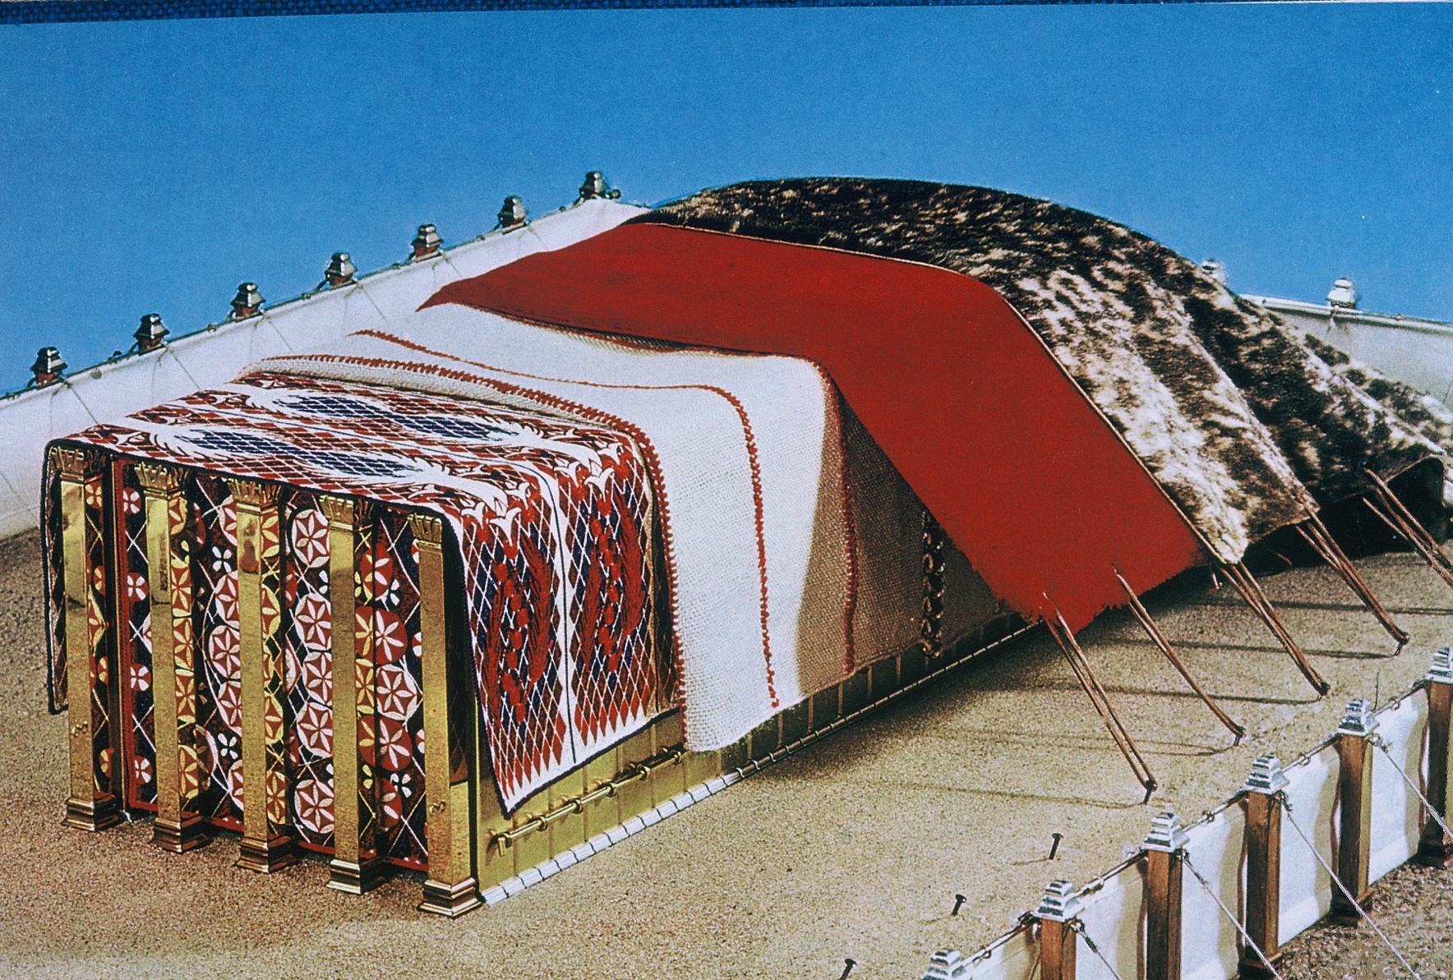

7) 65-0822M CHRIST.IS.REVEALED.IN.HIS.OWN.WORD_ JEFFERSONVILLE.IN V-4 N-10 SUNDAY_
« 52 † So, the Bible is the complete revelation of Jesus Christ. And It was wrote by prophets. Hebrews 1:1, in... "God, Who in sundry times spake to the fathers by the prophets, in this last day speaks to us through His Son, Jesus Christ," which was the prophets, all of them, put together. Jesus was Malachi; Jesus was Jeremiah, Isaiah, Elijah. All that they were, were in Him. And all that you are, and all I am, is in Him; Words, witnesses of the Word.
So It is not a book of systems, a code of moral ethics, neither is It a history book, or a book of theology. It is not. But It's a revelation of Jesus Christ, God Himself revealed, from Word to flesh. That's what It is. The Bible is the Word, and God is the flesh, God in... God is the Word, rather, and Jesus being the flesh. It's the revelation, how God (the Word) was manifested in human flesh, and revealed to us. And that's why He becomes a Son of God; He is a part of God. You understand? Now, He is not... The body is part of God, so much that it's a Son.

8) 65-0822M CHRIST.IS.REVEALED.IN.HIS.OWN.WORD_ JEFFERSONVILLE.IN V-4 N-10 SUNDAY_
« 141 † Then He was made actually human flesh, and dwelled among us, in the Person of Jesus Christ Himself, born of the virgin Mary. He come in that form so He could die, and went back into Heaven.
Now in this last days, He has promised to manifest Himself in the fullness again, of His flesh, in Spirit. See? "For as it was in the days of Sodom, so shall it be in the Coming of the Son of man." Now look at the Sodom, how it set, and what taken place. And Jesus Christ being manifested in bodily form, of His Church today, see, doing the same thing, same work, same things that He did all the time, never changes, the Eternal One. See? And upon earth today, He has manifested Himself in the human bodies, our human bodies that He has called, and done exactly the same thing He done in sundry times, and in the times of His flesh upon the earth. And doing the same thing today, because, "God in sundry times spoke to the fathers through the prophets, in this last days through His Son, Jesus Christ." See, the Son being revealed in the last days, God manifested in human flesh, setting just before Sodom's destruction, the end of the Gentile world. You see it?
There is three manifestations.

65-0822M CHRIST.IS.REVEALED.IN.HIS.OWN.WORD_ JEFFERSONVILLE.IN V-4 N-10 SUNDAY_
« 142 † Now, the next thing happens, is when it's all gathered up into that one Person, Jesus Christ, Bride and Body, at the physical return of the Lord Jesus. Making His three times... When He was brought on earth; killed, crucified, raised up. Manifesting Hisself in the form of His Body, which is His Bride, the Woman. You get it? She is part of His Body.
And the woman and man is just so close together, till they're just almost... They are the same. They ought to be, anyhow. There they are, see, they just exactly manifested the same. She is a part of him, because she was taken out from him.
And the Bride today is taken out from the body of Christ, which is acting and doing just exactly like He said It would do for this day, the Bride, the Queen; King and the Queen. All right.

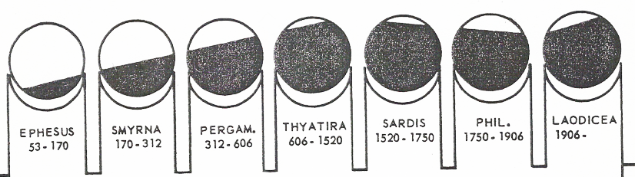

9) « 327-1 † LAODICEAN.CHURCH.AGE - CHURCH.AGE.BOOK CPT.9
Now this messenger of Malachi 4 and Revelation 10:7 is going to do two things. One: According to Malachi 4 he will turn the hearts of the children to the fathers. Two: He will reveal the mysteries of the seven thunders in Revelation 10 which are the revelations contained in the seven seals. It will be these Divinely revealed 'mystery-truths' that literally turn the hearts of the children to the Pentecostal fathers. Exactly so.

10) 63-0728 - "Christ Is The Mystery Of God Revealed"
His Body will do the works that He promised, like in Mark 16, and so forth. His body was not held in the grave, but was recognized with Him in the resurrection. Do you get it? [Congregation says, “Amen.”—Ed.] Then, the Body of His believing children will not be held in the grave when He comes, but will be recognized with Him, because He died for the purpose to resurrect His Bride, the Body. Recognized, because it is His Body, because it’s the Word. It’s so completely yielded from denomination things, to Him, and He is the Word. See? And it’s recognized with Him because now we have the first fruit of our resurrection, by know that we’ve passed from death unto Life, become prisoners of His. And God, proving to us by His personal Headship that He is the same yesterday and forever, by doing the same things through the Church that He did then, “He in Me, and I in Him, in you,” you know, so forth. That’s right.
His body was not held in the grave. Recognized with Him in the resurrection, same as He is now, listen, which means this: His Word, which He is, has been begin to be risen. The Word, that down through the age of Luther, Wesley, see, has begin to raise up to Its power; there It begin to move, then It moved a little more, now It’s coming up to a identification. See? Watch. Now, to the Life in the Body, is a vindication of the Rapture is at hand. When you see the Headship and the Body becoming One, and the fullness of the measure of His manifestation, shows that the Body is about ready to be received to the Headship.

