Notes used in the Message

11-0731pm - Chosen In Him Pt.2 - Samuel Dale
www.SpokenWordChurch.com

EPHESIANS 1:3-6
» 3 † ¶ Blessed be the God and Father of our Lord Jesus Christ, who hath blessed us with all spiritual blessings in heavenly places in Christ:

EPHESIANS 1:4
» 4 † According as he hath chosen us in him before the foundation of the world, that we should be holy and without blame before him in love:

EPHESIANS 1:5
» 5 † Having predestinated us unto the adoption of children by Jesus Christ to himself, according to the good pleasure of his will,

EPHESIANS 1:6
» 6 † To the praise of the glory of his grace, wherein he hath made us accepted in the beloved.

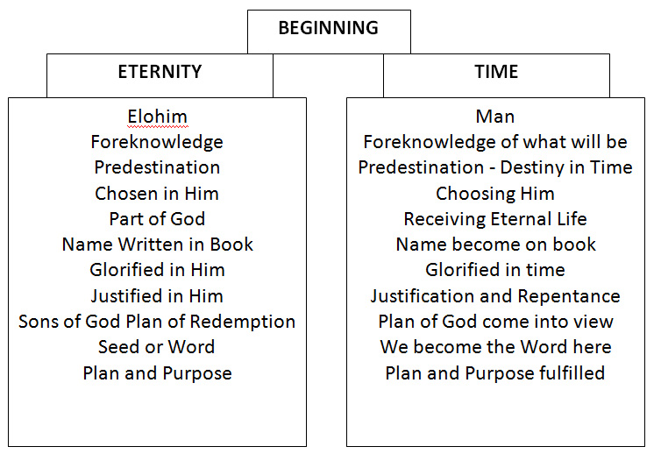
54-0306 THE.UNCONDITIONAL.COVENANT.THAT.GOD.MADE.WITH.HIS.PEOPLE
« E-29 † The father Abraham was the first one, that I know of, this side of the flood that was called by grace, by election. God chose Abraham, not because he was Abraham, not because he was any good person. God chose him because he was elected. God did it.
54-0314 WHY.I'M.PRAYING.FOR.THE.SICK_ COLUMBUS.OH SUNDAY_
« E-18 † Well, we could take much time on that, but just to show you that it's truth. Jesus said, "No man can come to Me except My Father draws Him first." So man don't seek God; God seeks man. And God calls men by election (See?), fore--foreknowledge of God. Like when, Jesus Christ, when He was born, He was the Son of God. He couldn't help 'cause He was the Son of God. He was foreordained the Son of God. Before the world begin, He was the Son of God. And He was the woman's Seed from the garden of Eden that was to bruise the serpent's head. He had nothing to do with it. It was already planned out.
When Moses was born, he was a proper child, not because he was Moses, not because he had done something, but because God chose him before he was born.
54-0721 SIRS.BE.OF.A.GOOD.CHEER_ CHICAGO.IL WEDNESDAY_
« E-24 † When Jesus Christ, He was a--He was a Son of God, all the way from the garden of Eden, the woman's Seed. Is that right?
Moses, when he was born, he couldn't help 'cause... He never made hisself Moses. When he was born, he was a proper child. God had raised him up.
And John the Baptist (seven hundred and twelve years before he was born, the prophet Isaiah saw him and said, "He's the voice of one crying in the wilderness.), he had nothing to do about being the forerunner of Christ. God chose him before the foundation of the world to be the forerunner of Christ.
I believe it was Jeremiah said... God told Jeremiah, said, "Before you was even formed in your mother's womb, I knew you, and sanctified you, and ordained you a prophet to the nations. Is that right? Before he was ever formed in his mother's womb... See? "Who taking thought can add cubit to his stature?"
64-0402 JEHOVAH.JIREH.1_ LOUISVILLE.MS THURSDAY_
« 17 † They probably, he was a farmer, lived in the valley of the Shinar there, and lived an ordinary life. He--he probably went out in the daytime, and got his meat from the bush, and picked berries, and lived that sort of a life. Just an ordinary man, there was nothing special about him. But one day, God called him. That's what made the difference, when God made the call.
18 And that's the way it is to any life. It takes God. It isn't what you do; it's what God does. See? You say, "I sought God. I sought God." You're mistaken. No man seeks God. God seeks the man. See? It's not you seeking God; it's God seeking you.
19 Jesus said, "You haven't chose Me, but I chose you." See? So you're chose before the foundation of the world, or you wasn't chose at all. He just come to redeem that name. And all whose names are not on that Lamb's Book of Life... before the foundation of the world, is the only ones going to be there, anyhow. See? You were chose in Him before the foundation of the world. When the Lamb was chosen, then you were chosen with Him, before the foundation.
20 And you are, as I said last night, an attribute of God's thinking. See, that's the only way you can be Eternal, and only form of Eternal Life. There is only one form of Eternal Life, and that's God. So, that's all, He is the One that's Eternal.

