WHO IS THIS SON OF MAN ?
PART 59

64-0705 THE.MASTERPIECE_ JEFFERSONVILLE.IN V-4 N-7 SUNDAY_
« 176 † Notice the great masterpiece, of the family. The husband and wife cannot be truly a family unless they are one. They have to be. If they're not, they're not a good family; wife pulling one way, and the husband another. That would make an awful family. But in agreement, with love one to the other, that's a family. And now that was God's masterpiece, and now all the true family here portrays that. See?
And now the Masterpiece family has come again, Christ and His Bride, ready to come. The Second Adam, Second Eve, ready now to return back to their Home. And the whole picture has been redemption. From where it was, bringing it back, see, just exactly bringing it back again.

JOHN 1:1 & 14
» 1 † ¶ In the beginning was the Word, and the Word was with God, and the Word was God.
» 14 † And the Word was made flesh, and dwelt among us, (and we beheld his glory, the glory as of the only begotten of the Father,) full of grace and truth.

I THESSALONIANS 4:4
» 4 † That every one of you should know how to possess his vessel in sanctification and honour;

ROMANS 12:2
» 2 † And be not conformed to this world: but be ye transformed by the renewing of your mind, that ye may prove what is that good, and acceptable, and perfect, will of God.

II PETER 1:1
» 1 † ¶ Simon Peter, a servant and an apostle of Jesus Christ, to them that have obtained like precious faith with us through the righteousness of God and our Saviour Jesus Christ:
» 2 † Grace and peace be multiplied unto you through the knowledge of God, and of Jesus our Lord,
» 3 † According as his divine power hath given unto us all things that pertain unto life and godliness, through the knowledge of him that hath called us to glory and virtue:
» 4 † Whereby are given unto us exceeding great and precious promises: that by these ye might be partakers of the divine nature, having escaped the corruption that is in the world through lust.
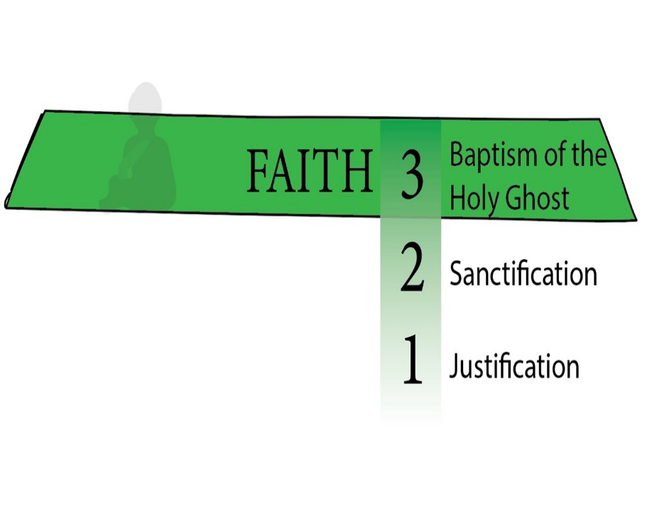

FIRST STAGE – THE BIRTH

BAPTISM OF THE HOLY GHOST
I PETER 1:22-25
» 22 † Seeing ye have purified your souls in obeying the truth through the Spirit unto unfeigned love of the brethren, see that ye love one another with a pure heart fervently:
» 23 † Being born again, not of corruptible seed, but of incorruptible, by the word of God, which liveth and abideth for ever.

HEBREWS 6:1
» 1 † ¶ Therefore leaving the principles of the doctrine of Christ, let us go on unto perfection; not laying again the foundation of repentance from dead works, and of faith toward God,
» 2 † Of the doctrine of baptisms, and of laying on of hands, and of resurrection of the dead, and of eternal judgment.
» 3 † And this will we do, if God permit.

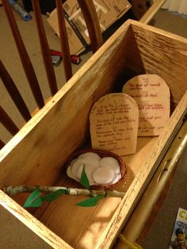

ARK – SYMBOL OF THE SON OF MAN.

55-0522 THE.ARK_ JEFFERSONVILLE.IN V-26 N-18 SUNDAY_
Now, watch the ark of the covenant. He said, "You shall make it out of acacia wood and overlay it with gold." Anyone who knows the Scripture, know that gold speaks of Deity, and wood speaks of humanity. See He said, "You shall cover it, overlay it with gold, over the wood." That's Deity over the wood: Christ over the Church, inside and out, Deity, overlaid.
« 137 † You'll have a lid on top of it. It'll be a mercy seat, and all the laws will rest in it. But before you...?... you sprinkle it over with blood. The law speaks of judgment. But between the law and the congregation, there was something for Deity stood in its place: type of Christ. Between the wrath of God, the judgment in hell, between that and the believer stands Deity Himself, Christ, standing in the way with an atonement made to save us from our sins and to heal us from our sickness. Deity stands in the way between judgment.

55-1007 THE.POWER.OF.DECISION_ CHICAGO.IL FRIDAY_
« E-28 † Put Aaron's rod in there, an old dead almond tree. But as it went under the Shekinah Glory, everything it was, was restored again. That's the way a sinner is when he goes under the Shekinah Glory of the Holy Spirit, the veils drop behind him, everything that he ought to have been, a son of God blooms out in him again. Amen.
Remember, overnight it budded, blossomed, and growed almonds on it, fruits of the Spirit: love, joy, long-suffering, goodness, gentleness, patience. That's what we need to get in the third step, get over into the Shekinah Glory where that little sacred Light was hanging over the--the mercy seat.

55-1110 A.HIDDEN.LIFE.IN.CHRIST_ SAN.FERNANDO.CA THURSDAY_
« E-25 † Notice, every year the high priest entered into that place. The congregation followed him up. And when he went into this great place where the veil dropped behind him, the inner courts, the holiest of holies, no one dared to go after him. Then he was alone with God.
What a beautiful picture it is today of a consecrated life who, once enters into with Christ, dead to the things of the world, hid away with God, and the veil's dropped down around, and all the world's shut off. Then Christianity and religion becomes a pleasure to every believer.
Today people just have enough religion to make them miserable, knowing that they ought to do this, they're trying to escape hell. Well, if that's the way I felt about it, brother, I don't know what I would do.

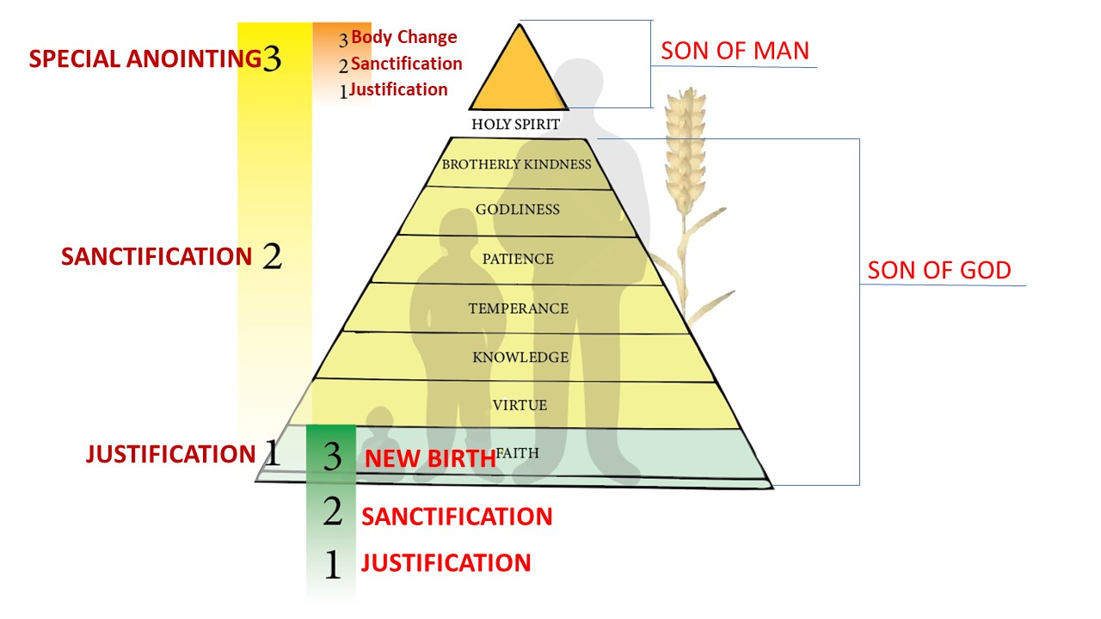

ENEMIES OF THE CROSS, GET TO THE CROSS AND THEN CARRY YOUR CROSS
CROSS WAS MADE OUT OF WOOD, OVERLAID WITH DEITY
THE VICTIM DID NOT CARRY THE WHOLE CROSS, BUT ONLY THE CROSS-BEAM.

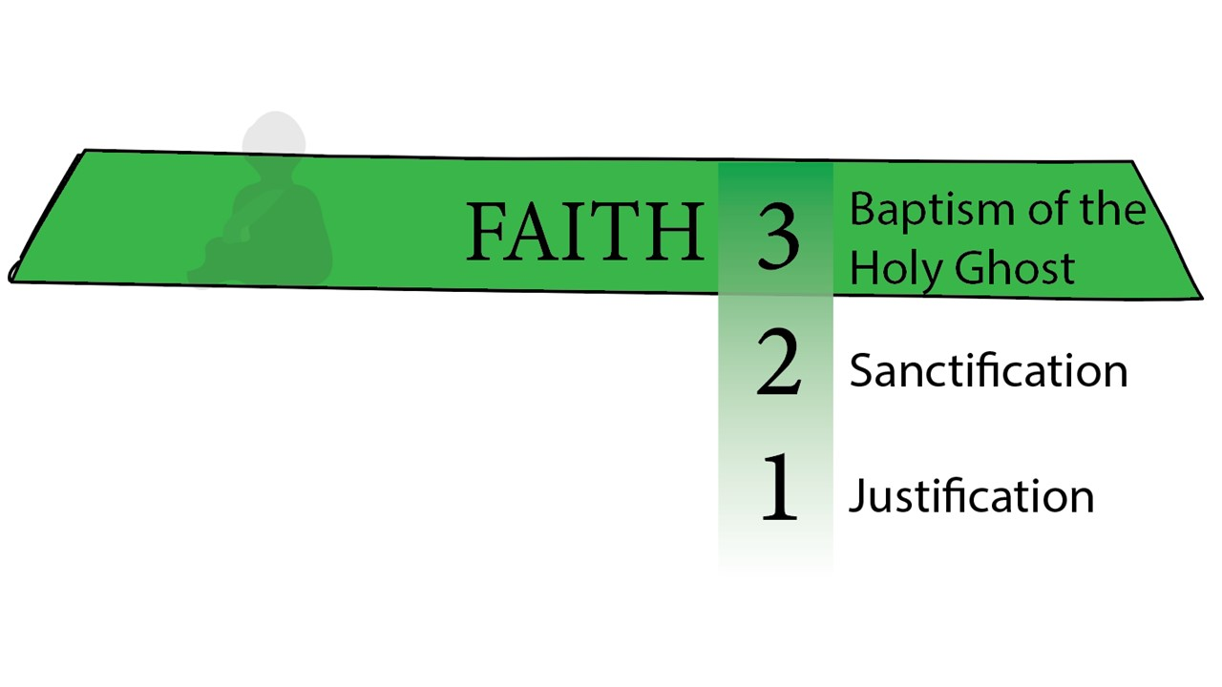

PHILIPPIANS 3:18
» 18 † (For many walk, of whom I have told you often, and now tell you even weeping, that they are the enemies of the cross of Christ:
» 19 † Whose end is destruction, whose God is their belly, and whose glory is in their shame, who mind earthly things.)

COLOSSIANS 2:14
» 14 † Blotting out the handwriting of ordinances that was against us, which was contrary to us, and took it out of the way, nailing it to his cross;

MATTHEW 10:37
» 37 † He that loveth father or mother more than me is not worthy of me: and he that loveth son or daughter more than me is not worthy of me.
» 38 † And he that taketh not his cross, and followeth after me, is not worthy of me.
» 39 † He that findeth his life shall lose it: and he that loseth his life for my sake shall find it.

LUKE 9:23
» 23 † And he said to them all, If any man will come after me, let him deny himself, and take up his cross daily, and follow me.
» 24 † For whosoever will save his life shall lose it: but whosoever will lose his life for my sake, the same shall save it.

I CORINTHIANS 15:31
» 31 † I protest by your rejoicing which I have in Christ Jesus our Lord, I die daily.

« 117-1 † SMYRNAEAN.CHURCH.AGE - CHURCH.AGE.BOOK CPT.4
Why does He stand by? The reason is in Romans 8:17-18,
"And if children, then heirs, heirs of God, and joint-heirs with Christ; if so be that we suffer with Him, that we may be also glorified together.
For I reckon that the sufferings of this present time are not worthy to be compared with the glory which shall be revealed in us."
Unless we suffer with Him we cannot reign with Him. You have to suffer to reign. The reason for this is that character simply is never made without suffering. Character is a VICTORY, not a gift. A man without character can't reign because power apart from character is Satanic. But power with character is fit to rule. And since He wants us to share even His throne on the same basis that He overcame and is set down in His Father's throne, then we have to overcome to sit with Him. And the little temporary suffering we go through now is not worthy to be compared to the tremendous glory that will be revealed in us when He comes. Oh, what treasures are laid up for those who are willing to enter into His kingdom through much tribulation.

65-0725M THE.ANOINTED.ONES.AT.THE.END.TIME_ JEFFERSONVILLE.IN V-5 N-3 SUNDAY_
I wasn't the One that appeared down on the river; I was only standing there when He appeared. I'm not the One that performs these things and foretells these things that happens as perfect they are; I'm only one that's near when He does it. I was only a voice that He used, to say It. It wasn't what I knew; it's what I just surrendered myself to, that He spoke through. It isn't me, it wasn't the seventh angel, oh, no; it was the manifestation of the Son of man. It wasn't the angel, his message; it was the mystery that God unfolded. It's not a man; it's God. The angel was not the Son of man; he was the messenger from the Son of man. The Son of man is Christ; He is the One that you're feeding on. You're not feeding on a man; a man, his words will fail. But you're feeding on the unfailing Body-Word of the Son of man.

62-1104M BLASPHEMOUS.NAMES_ JEFFERSONVILLE.IN V-3 N-21 SUNDAY_
« 135 † Now you say, "Brother Branham, do we, should we speak with tongues?" Absolutely. That's gifts of God. But those gifts of God, without these virtues in them, makes a stumble block to the unbeliever. It's not accepted by God.
136 This has to be first. And when you have faith, virtue, knowledge, temperance, patience, godliness, and brotherly love, then the Holy Ghost comes down and seals you as a unit, the same as He seals the church ages as a unit. The way He makes His Bride is the way He makes His individual; made out of same material, like Eve was made out of Adam, a rib from the side. Here is the things that you have to have first. You can't impersonate them. You can't imitate them. They've got to be God-sent and God-born. Imitation only causes confusion.

62-1111E WHY.I'M.AGAINST.ORGANIZED.RELIGION_ JEFFERSONVILLE.IN V-12 N-1 SUNDAY_
« 254 † And that's the way God does the Church. He beats every creed, every denomination, every man-made dogma, until He sees His Own Life reflecting in you. "If I do not the works of My Father, believe Me not." See? If what is purposed to the Church, the Life that was in Christ isn't reflecting in you, don't you stand still if you haven't got patience, virtue, all these things, and temperance, and--and things, and godliness, and brotherly kindness, and all these things that's required of you.

62-1013 THE.INFLUENCE.OF.ANOTHER_ JEFFERSONVILLE.IN V-4 N-11 SATURDAY_
Now, we want you to go to your own Sunday school, if you have one. But if you have no Sunday school, and you like to be with us, I want to speak in the morning, and put it on a blackboard, and teach on The Full Stature Of A Perfect Man, and draw it out, in on the blackboard, and show God's requirements and how we come to the perfect stature of--of a perfect man, before God.

62-1014M THE.STATURE.OF.A.PERFECT.MAN_ JEFFERSONVILLE.IN V-2 N-18 SUNDAY_
« 33 † So now, let us read now, First Peter, or... Second Peter, rather, the 1st chapter, portion of It.
Simon Peter, a servant and an apostle of Jesus Christ, to them that have obtained like precious faith with us through the righteousness of God and our Saviour Jesus Christ:
34 I like the way that's stated right there, because my whole subject this morning is based on faith. See? Let me read that again. Listen close.
Simon Peter, a servant and an apostle of Jesus Christ, to them that obtain--obtained like precious faith... through the righteousness of God... our Saviour and Jesus Christ:
35 Notice, He is saying, that, "I have obtained this faith, and I'm addressing this to them that has obtained the like precious faith." I want... It's not to the outside world. This is to the Church, see, those that are in Christ.
Grace and peace be multiplied unto you through the knowledge of God, and (through) of Jesus Christ our Lord,
According as his divine power has given unto us all things... his divine power now has given unto us all things that pertain unto life... godliness, through the knowledge of him that has called us to glory and virtue:
Whereby are we given unto... given unto us exceeding great and precious promises: that by these (these promises) we might be partakers of the divine nature,...
« 36 † Now let that soak real deep now. Not preaching this morning; we just teaching this lesson. "Divine nature." Let me read that 4th verse again now, so you won't miss it. "Whereby we are given..."
Whereby are given unto us exceeding great and precious promises: that by these (these promises) we might be partakers of the divine nature, having escaped the corruption that is in the world through lust.
37 See, "the world," we've escaped that now. He's addressing this to the Church. That's why we're here this morning, is to find out what is the way, what is God's requirement. There's not a person in here, that loves God, but wants to--wants to become more like Christ. Now it's laid out here. Every Christian!

62-1014M THE.STATURE.OF.A.PERFECT.MAN_ JEFFERSONVILLE.IN V-2 N-18 SUNDAY_
« 45 † That's the way it is with Christ. See? We've got to be so in love with Him, till when we ask for something, and He doesn't give it to us, that doesn't shake us a bit. See? See? Why? And the only way you can do that, is to become partakers of His Divine nature, then you'll understand the reason He can't give it to you. "Partakers of His Divine nature."

EPHESIANS 4:11
» 11 † And he gave some, apostles; and some, prophets; and some, evangelists; and some, pastors and teachers;
» 12 † For the perfecting of the saints, for the work of the ministry, for the edifying of the body of Christ:
» 13 † Till we all come in the unity of the faith, and of the knowledge of the Son of God, unto a perfect man, unto the measure of the stature of the fulness of Christ:
» 14 † That we henceforth be no more children, tossed to and fro, and carried about with every wind of doctrine, by the sleight of men, and cunning craftiness, whereby they lie in wait to deceive;
» 15 † But speaking the truth in love, may grow up into him in all things, which is the head, even Christ:
» 16 † From whom the whole body fitly joined together and compacted by that which every joint supplieth, according to the effectual working in the measure of every part, maketh increase of the body unto the edifying of itself in love.

62-1014M THE.STATURE.OF.A.PERFECT.MAN_ JEFFERSONVILLE.IN V-2 N-18 SUNDAY_
« 94 † Well, now that's the way it is, trying to--to manufacture Christianity. You can't do it. The first thing you've got to do, is be born again. You've got to be changed. See? And when you're changed, you become a new creation. Now you're getting right, now. See? Now you don't have to worry about the feathers, it'll take care of itself, when--when you are born again. Yes, sir.
95 Like I've always said. You take a--a hog, scrub him up and put a tuxsailor suit on him, or tuxedo suit, rather, on him, and turn him out there; he go right to a mud hole and wallow. Cause, you see, it wouldn't do any good. He's a hog. That's his nature. Wallowing is his nature. You've got to change his nature, and (he) the rest of it will take care of itself.
« 96 † Now notice. You must be born again, that is, changed. There's got to be a change.
97 You say, "Well, Brother Branham, I know this certain woman over here, why, she never did do anything wrong. She's a good woman. Or, this such-and-such a man, he's a good man. He never does anything. You know he doesn't harm anybody." That doesn't mean one thing. He might make a good neighbor, but he isn't a Christian until he's born again.
98 Jesus said, "Except a man be born again," Saint John 3, that, "he can't even see the Kingdom." Now, that means, see, it means to "understand."
99 You look at anything, say, "I just don't see it." You mean you don't understand it.

II PETER 1:1
» 1 † ¶ Simon Peter, a servant and an apostle of Jesus Christ, to them that have obtained like precious faith with us through the righteousness of God and our Saviour Jesus Christ:
» 2 † Grace and peace be multiplied unto you through the knowledge of God, and of Jesus our Lord,
» 3 † According as his divine power hath given unto us all things that pertain unto life and godliness, through the knowledge of him that hath called us to glory and virtue:
» 4 † Whereby are given unto us exceeding great and precious promises: that by these ye might be partakers of the divine nature, having escaped the corruption that is in the world through lust.
» 5 † ¶ And beside this, giving all diligence,

GREEK LEXICON -- STRONG'S NUMBER 471

-- haste (2)
-- care (1)
-- forwardness (1)
-- earnest care (1)
-- carefulness (1) [12]
1) haste, with haste
2) earnestness, diligence: earnestness in accomplishing, promoting, or striving after anything; to give all diligence, interest one's self most earnestly

add to your faith virtue; and to virtue knowledge;
» 6 † And to knowledge temperance; and to temperance patience; and to patience godliness;
» 7 † And to godliness brotherly kindness; and to brotherly kindness charity.
» 8 † For if these things be in you, and abound,

GREEK LEXICON -- STRONG'S NUMBER 4127
-- abundant (1)
-- have over (1)
-- make to increase (1) [9]
1) to superabound of things, to exist in abundance; to increase, be augmented
2) to make to increase: one in a thing

they make you that ye shall neither be barren nor unfruitful in the knowledge of our Lord Jesus Christ.
» 9 † But he that lacketh these things is blind, and cannot see afar off, and hath forgotten that he was purged from his old sins.
» 10 † Wherefore the rather, brethren, give diligence to make your calling and election sure: for if ye do these things, ye shall never fall:
» 11 † For so an entrance shall be ministered unto you abundantly into the everlasting kingdom of our Lord and Saviour Jesus Christ.

