WHO IS THIS SON OF MAN ?
PART 57

65-1031M POWER.OF.TRANSFORMATION_ PRESCOTT.AZ V-17 N-1 SUNDAY_
« 76 † See, whatever it is, that's what we want. And I believe it was David, said, "I would rather be a doormat at the house of the Lord, than to dwell in tents with the wicked." You see, no matter what it is, "take my place."
77 Sometimes you have to separate from everything that's dear on earth, to you, to take your position that God has called you to. I'm sure you can read between the lines, what I'm saying. See? Sometimes the very dearest person on earth, you have to shake hands with them; just take your position in Christ, to where God has called you. See? But what is God doing? Transforming you from what you was. Maybe a daughter or a son, or whatever it is, from a lovely family sometimes, He places you somewhere else. Because, it's His way of doing it, see, by the renewing of your mind, to obey the Word of God, regardless of what the price is. See? These things don't come... It didn't call...
« 78 † Our redemption wasn't a cheap thing, it was the Son of God had to die for us. See? It isn't... Things of value come of great price.

JOHN 1:1 & 14
» 1 † ¶ In the beginning was the Word, and the Word was with God, and the Word was God.
» 14 † And the Word was made flesh, and dwelt among us, (and we beheld his glory, the glory as of the only begotten of the Father,) full of grace and truth.

I THESSALONIANS 4:4
» 4 † That every one of you should know how to possess his vessel in sanctification and honour;

ROMANS 12:2
» 2 † And be not conformed to this world: but be ye transformed by the renewing of your mind, that ye may prove what is that good, and acceptable, and perfect, will of God.

II PETER 1:1
» 1 † ¶ Simon Peter, a servant and an apostle of Jesus Christ, to them that have obtained like precious faith with us through the righteousness of God and our Saviour Jesus Christ:
» 2 † Grace and peace be multiplied unto you through the knowledge of God, and of Jesus our Lord,
» 3 † According as his divine power hath given unto us all things that pertain unto life and godliness, through the knowledge of him that hath called us to glory and virtue:
» 4 † Whereby are given unto us exceeding great and precious promises: that by these ye might be partakers of the divine nature, having escaped the corruption that is in the world through lust.
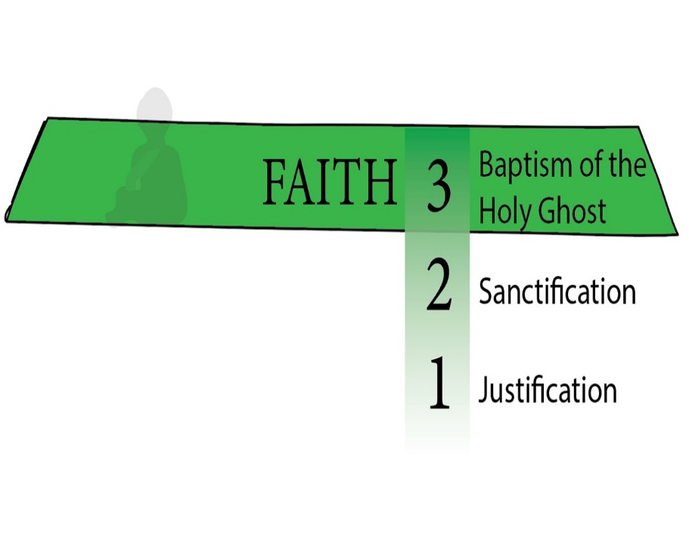

FIRST STAGE – THE BIRTH

ROMANS 8:14-17
» 14 † For as many as are led by the Spirit of God, they are the sons of God.
» 15 † For ye have not received the spirit of bondage again to fear; but ye have received the Spirit of adoption, whereby we cry, Abba, Father.
» 16 † The Spirit itself beareth witness with our spirit, that we are the children of God:
» 17 † ¶ And if children, then heirs; heirs of God, and joint-heirs with Christ; if so be that we suffer with him, that we may be also glorified together.

JUSTIFICATION

SANCTIFICATION - soul
- 55-1110 A.HIDDEN.LIFE.IN.CHRIST
He said He'd give you a new spirit. Now, that spirit isn't God's spirit; that's your spirit. God gives you a new spirit, then He says, "I'll put my Spirit in him." But the thing God has to do is give you a new spirit, make your nature a little more gentle and settle down, or He couldn't even live with you.

BAPTISM OF THE HOLY GHOST
I PETER 1:22-25
» 22 † Seeing ye have purified your souls in obeying the truth through the Spirit unto unfeigned love of the brethren, see that ye love one another with a pure heart fervently:
» 23 † Being born again, not of corruptible seed, but of incorruptible, by the word of God, which liveth and abideth for ever.

HEBREWS 6:1
» 1 † ¶ Therefore leaving the principles of the doctrine of Christ, let us go on unto perfection; not laying again the foundation of repentance from dead works, and of faith toward God,
» 2 † Of the doctrine of baptisms, and of laying on of hands, and of resurrection of the dead, and of eternal judgment.
» 3 † And this will we do, if God permit.

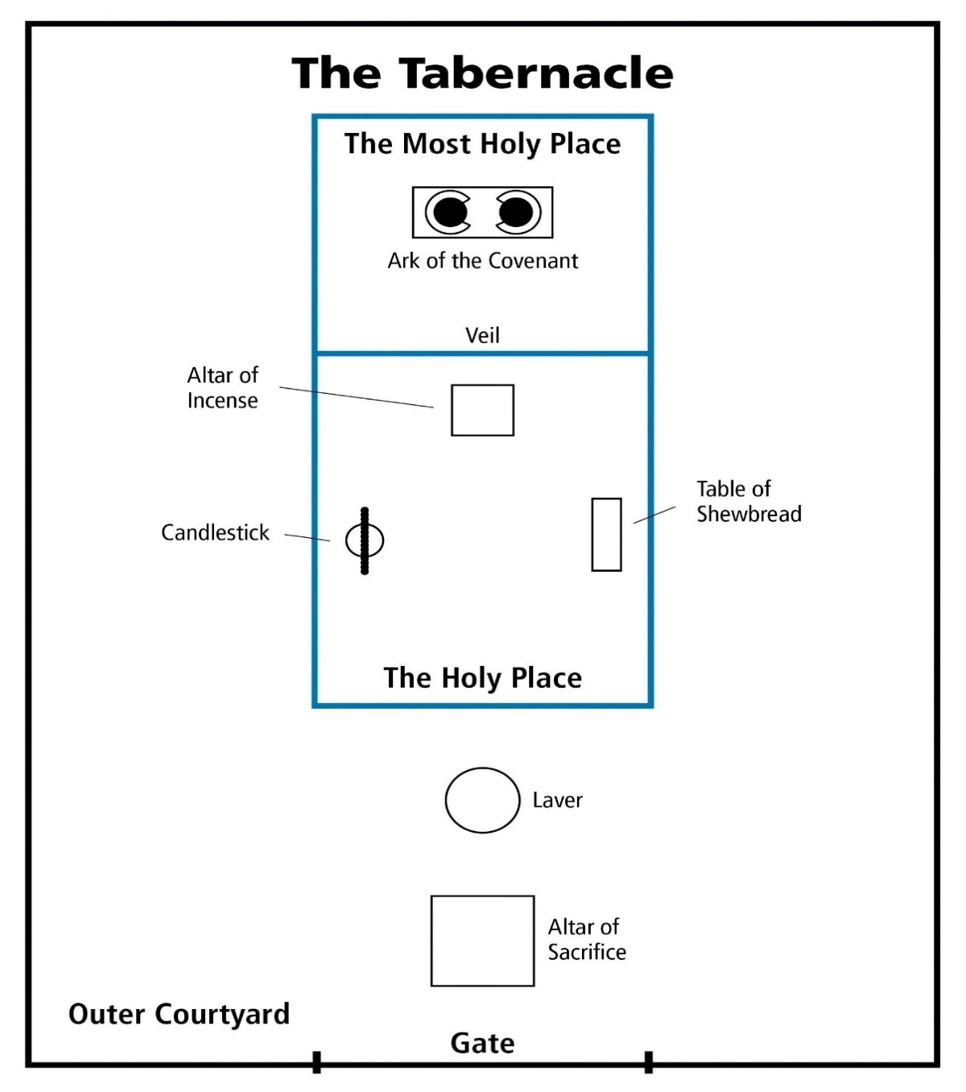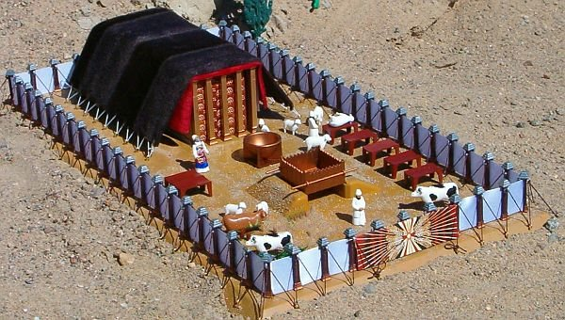

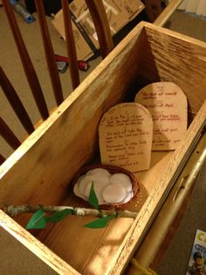

ARK – SYMBOL OF THE SON OF MAN.

55-0522 THE.ARK_ JEFFERSONVILLE.IN V-26 N-18 SUNDAY_
Now, watch the ark of the covenant. He said, "You shall make it out of acacia wood and overlay it with gold." Anyone who knows the Scripture, know that gold speaks of Deity, and wood speaks of humanity. See He said, "You shall cover it, overlay it with gold, over the wood." That's Deity over the wood: Christ over the Church, inside and out, Deity, overlaid.
« 137 † You'll have a lid on top of it. It'll be a mercy seat, and all the laws will rest in it. But before you...?... you sprinkle it over with blood. The law speaks of judgment. But between the law and the congregation, there was something for Deity stood in its place: type of Christ. Between the wrath of God, the judgment in hell, between that and the believer stands Deity Himself, Christ, standing in the way with an atonement made to save us from our sins and to heal us from our sickness. Deity stands in the way between judgment.

61-0101 REVELATION.CHAPTER.FOUR.2_ JEFFERSONVILLE.IN ROJC 585-643 SUNDAY_
« 228 † There you are! Your daily walk, your daily talk, your daily behavior, your heart, your soul, and all, "Holy, holy, holy, unto the Lord." No roots of bitterness, no nothing else, "Holy, holy, holy, unto the Lord. Holy, holy, holy, unto the Lord," as we begin to approach in behalf of our brother. Whosoever will may come, anointed, Blood in front of him, the Blood going before him, playing "Holy, holy, holy, unto the Lord."
Now, that was the outer courts, the holy place. And the Holiest of holies, that was God's sanctuary on earth.

FRUITS

NUMBERS 17:1
» 7 † And Moses laid up the rods before the LORD in the tabernacle of witness.
» 8 † ¶ And it came to pass, that on the morrow Moses went into the tabernacle of witness; and, behold, the rod of Aaron for the house of Levi was budded, and brought forth buds, and bloomed blossoms, and yielded almonds.

ROMANS 6:4
» 4 † Therefore we are buried with him by baptism into death: that like as Christ was raised up from the dead by the glory of the Father, even so we also should walk in newness of life.
» 5 † For if we have been planted together in the likeness of his death, we shall be also in the likeness of his resurrection:
» 6 † Knowing this, that our old man is crucified with him, that the body of sin might be destroyed, that henceforth we should not serve sin.
» 7 † For he that is dead is freed from sin.

55-1007 THE.POWER.OF.DECISION_ CHICAGO.IL FRIDAY_
« E-28 † Put Aaron's rod in there, an old dead almond tree. But as it went under the Shekinah Glory, everything it was, was restored again. That's the way a sinner is when he goes under the Shekinah Glory of the Holy Spirit, the veils drop behind him, everything that he ought to have been, a son of God blooms out in him again. Amen.
Remember, overnight it budded, blossomed, and growed almonds on it, fruits of the Spirit: love, joy, long-suffering, goodness, gentleness, patience. That's what we need to get in the third step, get over into the Shekinah Glory where that little sacred Light was hanging over the--the mercy seat.

56-0101 WHY.ARE.PEOPLE.SO.TOSSED.ABOUT_ JEFFERSONVILLE.IN V-2 N-14 SUNDAY_
« 20-3 † And now, after they left that second court, sanctification, they entered into this consecrated life, entered into the Presence of God. And while they were in there, there's where they had all these glorious things. What a very beautiful type that in there, anything dead come in, lived again. Did you ever think of that? They took Aaron's rod and laid Aaron's rod in the presence of this holy place; and when they did, in one night's time it budded, blossomed, and yielded almonds: in one night's time. Think of it. In the Presence of God this old dead rod, lying there in the Presence of God budded, blossomed, and yielded almonds in one night. What was it then? What kind of a rod was it? It was an almond tree rod. That's what he taken it from; the stick was off of an almond tree. And you are a stick some kind; and you're--you was taken off the branch of humanity, which was God's created son in the beginning. You may be fallen, dead, alienated from God; but by that in creation, you were created to be a son of God. You may bounce around, and be respected and honored out here in the courts, but if you ever get into that glorious place and hid away with God, you'll yield what you're supposed to do.

55-1110 A.HIDDEN.LIFE.IN.CHRIST_ SAN.FERNANDO.CA THURSDAY_
« E-25 † Notice, every year the high priest entered into that place. The congregation followed him up. And when he went into this great place where the veil dropped behind him, the inner courts, the holiest of holies, no one dared to go after him. Then he was alone with God.
What a beautiful picture it is today of a consecrated life who, once enters into with Christ, dead to the things of the world, hid away with God, and the veil's dropped down around, and all the world's shut off. Then Christianity and religion becomes a pleasure to every believer.
Today people just have enough religion to make them miserable, knowing that they ought to do this, they're trying to escape hell. Well, if that's the way I felt about it, brother, I don't know what I would do.
Oh, get in with Christ. Shut off from the things of the world, for, to commune with Him is a pleasure. It's beautiful. It's something that fills and satisfies the soul, something that gives you peace that passes all understanding. All the crosses become flying wings. All the burdens are chariot wheels. Oh, you can fly away.
Now, as... He can let that Spirit grow and take out all the roots of bitterness, and press God's way through him again; he can become back in the same condition that he was when he was in the garden of Eden. Jesus said in Mark 11:24:

62-1014M THE.STATURE.OF.A.PERFECT.MAN_ JEFFERSONVILLE.IN V-2 N-18 SUNDAY_
351 And now we've put the Blood of Jesus Christ in, see, and that brings the faith of Jesus Christ, the virtue of Jesus Christ, the knowledge of Jesus Christ, the temperance of Jesus Christ, the patience of Jesus Christ, the godliness of Jesus Christ, the brotherly kindness of Jesus Christ, and the love of God, which is Jesus Christ. He's the Head and controls you. And your feet is the foundation, faith. Amen! Controlled by the Head, takes the...?... There you are. There is the perfect man of God, when he possesses these virtues

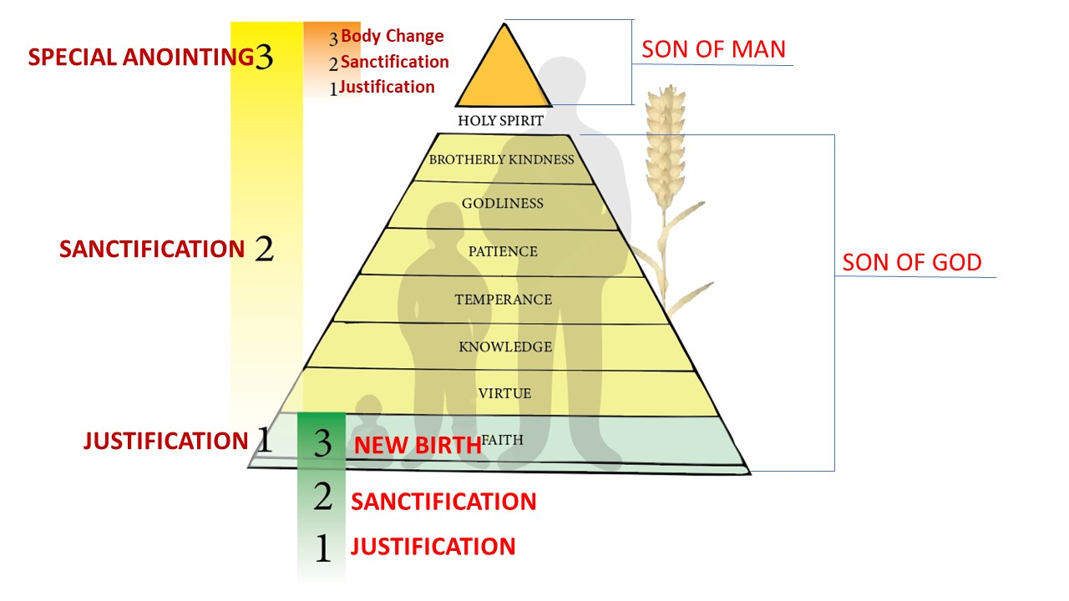

ENEMIES OF THE CROSS, GET TO THE CROSS AND THEN CARRY YOUR CROSS
CROSS WAS MADE OUT OF WOOD, OVERLAID WITH DEITY

The Process
Based on Roman literature as well as descriptions in the provinces, crucifixion was an established routine. There were special military teams led by a centurion, and in the provinces, the soldiers were selected from the local auxiliaries (natives who had joined the Roman army). The victim was stripped and then lashed (scourged). As part of the public humiliation, he/she was led through the streets and remained naked. Christian art portrays Jesus with a decent loincloth on the cross, but the nakedness was maintained as part of the humiliation. There was a public plaque (titulus) indicating the crime. The shedding of blood and the concept of corpse contamination meant that the executions took place outside the city walls. The most popular spot was along one of the main roads leading into the city. This also served as propaganda purposes to demonstrate Roman law and order.
THE VICTIM DID NOT CARRY THE WHOLE CROSS, BUT ONLY THE CROSS-BEAM.

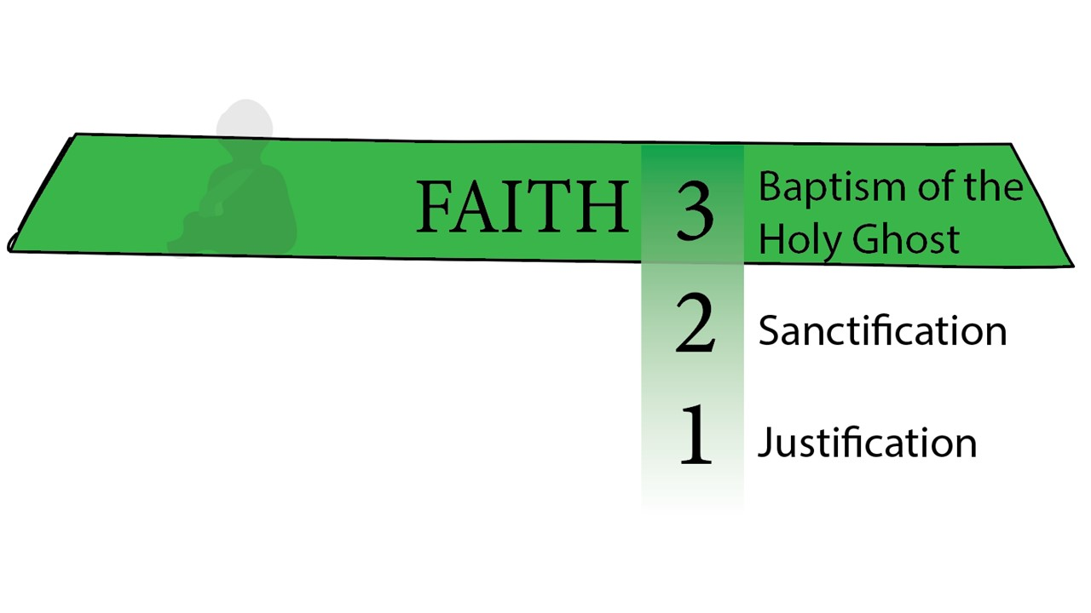
These killing fields contained permanent, upright poles. The victim did not carry the whole cross, but only the cross-beam. The combined pole and cross-beam weighed approximately 135-180 kg (300-400 pounds). After scourging (the trauma and the loss of blood), there was a risk that the victim could die before arriving at the site of execution. The necessity of keeping the victim alive led to the practice of the legions commandeering someone from the crowd to help carry the beam when the victim succumbed. This is the role of Simon of Cyrene in the gospel versions.
Upon arrival, the victim was either tied or nailed to the cross-beam which was then hoisted up and connected to the vertical pole (with ladders and pulleys). We have evidence of the use of nails from several sources. These were 13-18 cm (5-7 in) long tapered iron spikes.

PHILIPPIANS 3:18
» 18 † (For many walk, of whom I have told you often, and now tell you even weeping, that they are the enemies of the cross of Christ:
» 19 † Whose end is destruction, whose God is their belly, and whose glory is in their shame, who mind earthly things.)

COLOSSIANS 2:14
» 14 † Blotting out the handwriting of ordinances that was against us, which was contrary to us, and took it out of the way, nailing it to his cross;

I CORINTHIANS 1:17
» 17 † ¶ For Christ sent me not to baptize, but to preach the gospel: not with wisdom of words, lest the cross of Christ should be made of none effect.
» 18 † For the preaching of the cross is to them that perish foolishness; but unto us which are saved it is the power of God.

MATTHEW 10:37
» 37 † He that loveth father or mother more than me is not worthy of me: and he that loveth son or daughter more than me is not worthy of me.
» 38 † And he that taketh not his cross, and followeth after me, is not worthy of me.
» 39 † He that findeth his life shall lose it: and he that loseth his life for my sake shall find it.

MATTHEW 16:24
» 24 † ¶ Then said Jesus unto his disciples, If any man will come after me, let him deny himself, and take up his cross, and follow me.
» 25 † For whosoever will save his life shall lose it: and whosoever will lose his life for my sake shall find it.

MARK 8:34
» 34 † And when he had called the people unto him with his disciples also, he said unto them, Whosoever will come after me, let him deny himself, and take up his cross, and follow me.

LUKE 9:23
» 23 † And he said to them all, If any man will come after me, let him deny himself, and take up his cross daily, and follow me.
» 24 † For whosoever will save his life shall lose it: but whosoever will lose his life for my sake, the same shall save it.

I CORINTHIANS 15:31
» 31 † I protest by your rejoicing which I have in Christ Jesus our Lord, I die daily.

LUKE 14:27
» 27 † And whosoever doth not bear his cross, and come after me, cannot be my disciple.

II PETER 1:1
» 1 † ¶ Simon Peter, a servant and an apostle of Jesus Christ, to them that have obtained like precious faith with us through the righteousness of God and our Saviour Jesus Christ:
» 2 † Grace and peace be multiplied unto you through the knowledge of God, and of Jesus our Lord,
» 3 † According as his divine power hath given unto us all things that pertain unto life and godliness, through the knowledge of him that hath called us to glory and virtue:
» 4 † Whereby are given unto us exceeding great and precious promises: that by these ye might be partakers of the divine nature, having escaped the corruption that is in the world through lust.
» 5 † ¶ And beside this, giving all diligence, add to your faith virtue; and to virtue knowledge;
» 6 † And to knowledge temperance; and to temperance patience; and to patience godliness;
» 7 † And to godliness brotherly kindness; and to brotherly kindness charity.
» 8 † For if these things be in you, and abound, they make you that ye shall neither be barren nor unfruitful in the knowledge of our Lord Jesus Christ.
» 9 † But he that lacketh these things is blind, and cannot see afar off, and hath forgotten that he was purged from his old sins.
» 10 † Wherefore the rather, brethren, give diligence to make your calling and election sure: for if ye do these things, ye shall never fall:
» 11 † For so an entrance shall be ministered unto you abundantly into the everlasting kingdom of our Lord and Saviour Jesus Christ.

62-1104M BLASPHEMOUS.NAMES_ JEFFERSONVILLE.IN V-3 N-21 SUNDAY_
« 135 † Now you say, "Brother Branham, do we, should we speak with tongues?" Absolutely. That's gifts of God. But those gifts of God, without these virtues in them, makes a stumble block to the unbeliever. It's not accepted by God.
136 This has to be first. And when you have faith, virtue, knowledge, temperance, patience, godliness, and brotherly love, then the Holy Ghost comes down and seals you as a unit, the same as He seals the church ages as a unit. The way He makes His Bride is the way He makes His individual; made out of same material, like Eve was made out of Adam, a rib from the side. Here is the things that you have to have first. You can't impersonate them. You can't imitate them. They've got to be God-sent and God-born. Imitation only causes confusion.

62-1111E WHY.I'M.AGAINST.ORGANIZED.RELIGION_ JEFFERSONVILLE.IN V-12 N-1 SUNDAY_
« 254 † And that's the way God does the Church. He beats every creed, every denomination, every man-made dogma, until He sees His Own Life reflecting in you. "If I do not the works of My Father, believe Me not." See? If what is purposed to the Church, the Life that was in Christ isn't reflecting in you, don't you stand still if you haven't got patience, virtue, all these things, and temperance, and--and things, and godliness, and brotherly kindness, and all these things that's required of you.

