WHO IS THIS SON OF MAN ?
PART 55
51-0729A THE.RESURRECTION.OF.LAZARUS_ ERIE.PA SUNDAY_
« E-67 † Then God told Aaron... Now, He said, "Now, don't try to keep any of that over. If you keep it over, it'll spoil."
That's what's the matter with a whole lot of the Pentecostal people. You keep it over. "I had an experience twenty years ago." Brother, that experience has got wiggletails in it today. What about right now?
You say, "When I received the baptism of the Holy Ghost, I had joy, peace, and suf--longsuffering." What about now? That experience back there is done gone. What about a new one today? Each day they gathered new manna. And a manna is a perfect type of the Holy Ghost coming from God, the Sustainer to take them through the wilderness, as the Spirit is the Sustainer for us today to take us through this journey. We're on our road to the promised land. Is that right?
"In My Father's house is many mansions. If it wasn't so, I would've told you. And I'll go and prepare a place for you." Is that right? We're on our way to the promised land.
Notice. And we're fed daily by the Holy Spirit coming down from God out of heaven, sweet to our souls like honey in the rock. I have to have it every hour of my life or I die. That's true. It has to come to me or I can't live. It'll come--have to come to you or you won't live. That's right.

JOHN 1:1 & 14
» 1 † ¶ In the beginning was the Word, and the Word was with God, and the Word was God.
» 14 † And the Word was made flesh, and dwelt among us, (and we beheld his glory, the glory as of the only begotten of the Father,) full of grace and truth.

I THESSALONIANS 4:4
» 4 † That every one of you should know how to possess his vessel in sanctification and honour;

ROMANS 12:2
» 2 † And be not conformed to this world: but be ye transformed by the renewing of your mind, that ye may prove what is that good, and acceptable, and perfect, will of God.

HEBREWS 4:15
» 15 † For we have not an high priest which cannot be touched with the feeling of our infirmities; but was in all points tempted like as we are, yet without sin.
» 16 † Let us therefore come boldly unto the throne of grace, that we may obtain mercy, and find grace to help in time of need.

FIRST STAGE – THE BIRTH

ROMANS 8:14-17
» 14 † For as many as are led by the Spirit of God, they are the sons of God.
» 15 † For ye have not received the spirit of bondage again to fear; but ye have received the Spirit of adoption, whereby we cry, Abba, Father.
» 16 † The Spirit itself beareth witness with our spirit, that we are the children of God:
» 17 † ¶ And if children, then heirs; heirs of God, and joint-heirs with Christ; if so be that we suffer with him, that we may be also glorified together.

JUSTIFICATION

SANCTIFICATION - soul
- 55-1110 A.HIDDEN.LIFE.IN.CHRIST
He said He'd give you a new spirit. Now, that spirit isn't God's spirit; that's your spirit. God gives you a new spirit, then He says, "I'll put my Spirit in him." But the thing God has to do is give you a new spirit, make your nature a little more gentle and settle down, or He couldn't even live with you.

BAPTISM OF THE HOLY GHOST
I PETER 1:22-25
» 22 † Seeing ye have purified your souls in obeying the truth through the Spirit unto unfeigned love of the brethren, see that ye love one another with a pure heart fervently:
» 23 † Being born again, not of corruptible seed, but of incorruptible, by the word of God, which liveth and abideth for ever.

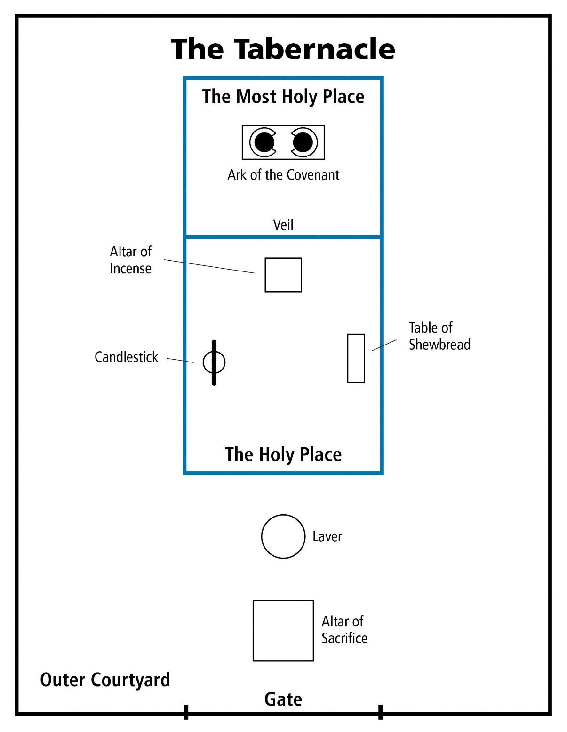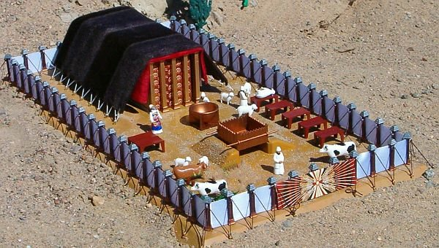

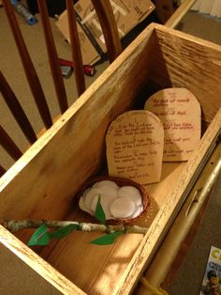

61-0101 REVELATION.CHAPTER.FOUR.2_ JEFFERSONVILLE.IN ROJC 585-643 SUNDAY_
« 222 † Now, notice these holy places. Now, when you come into the courts, the first was the courts, the outer courts. The next was the altar, where the sacrifices was offered, the brazen altar. Then outside of the brazen altar, there was a veil hung here that went into the Holy of holies; in there was the mercy seat, in there was the Cherubims. That's what I want to get to in our next lesson, those Cherubims overshadowing the mercy seat. Oh, my! I... We can just stay all month on it, see, on that Cherubim.
« 223 † Now, now notice as they entered in. The congregation could come there; the priests could stand here; but just the high priest could go in there, once a year, taking the blood with him.
And he had to be dressed a certain way, a certain garment; had to have a bell and a pomegranate, one to one another. And when he walked, he had to walk a certain way. As he walked, he played, "Holy, holy, holy, unto the Lord. Holy, holy, holy, unto the Lord," those bells and pomegranates ringing together, "Holy, holy, holy!" Why? He was approaching God, having the blood of the covenant in his hand, going before Him, bearing the blood.
Anointed (Oh, my!) with certain perfumes. His clothes had to be made by Holy Ghost-filled hand, registered hands make his clothes. The rose of Sharon, the anointing oil, poured it on his head, it run all down his beard and then down over. He was placing the royal perfume; a pomegranate and a bell; taking the blood of an innocent lamb; and he daresn't approach that veil outside... he'd die right where he was standing. So he had to go, walking a certain way, "Holy, holy, holy, unto the Lord. Holy, holy, holy," (approaching God) "unto the Lord. Holy, holy, holy!"
« 226 † And he went there and offered the blood on the mercy seat, once a year. And while he was in there, he was privileged to see the Shekinah Glory; when the Pillar of Fire, the amber Light that come down, that led the children out of Israel. He even smoked up the temple so no one could see It. The Glory of the Lord fell till it was all smoked up. And He came in Hisself, went in behind the veil and settled down on the mercy seat in the Holiest of holies. "Most Holy place," it's called, Holy of holies. And he had to be dressed a certain way, walk a certain way, anointed a certain way. He was a special person to go in there. How the congregation must have envied him!
But when Jesus died, the temple veil rent. Not only a high priest, but "whosoever will" can have that same anointing of the Shekinah Glory and walk a holy life, "Holy, holy, holy, unto the Lord," and approach in the very Presence of God, through the Blood of Jesus Christ before him. Take him with: "Lord Jesus, here lays a sick man, he's my brother. He's on the deathbed right now, to die. I'm approaching You, 'Holy, holy, holy, unto the Lord.'"
"What for?"
"As a high priest."
"What for?"
"In behalf of my brother. 'Holy, holy, holy, unto the Lord.'"
« 228 † There you are! Your daily walk, your daily talk, your daily behavior, your heart, your soul, and all, "Holy, holy, holy, unto the Lord." No roots of bitterness, no nothing else, "Holy, holy, holy, unto the Lord. Holy, holy, holy, unto the Lord," as we begin to approach in behalf of our brother. Whosoever will may come, anointed, Blood in front of him, the Blood going before him, playing "Holy, holy, holy, unto the Lord."
Now, that was the outer courts, the holy place. And the Holiest of holies, that was God's sanctuary on earth.

FRUITS

» NUMBERS 17
NUMBERS 17:1
» 1 † ¶ And the LORD spake unto Moses, saying,
» 2 † Speak unto the children of Israel, and take of every one of them a rod according to the house of their fathers, of all their princes according to the house of their fathers twelve rods: write thou every man's name upon his rod.
» 3 † And thou shalt write Aaron's name upon the rod of Levi: for one rod shall be for the head of the house of their fathers.
» 4 † And thou shalt lay them up in the tabernacle of the congregation before the testimony, where I will meet with you.
» 5 † And it shall come to pass, that the man's rod, whom I shall choose, shall blossom: and I will make to cease from me the murmurings of the children of Israel, whereby they murmur against you.
» 6 † And Moses spake unto the children of Israel, and every one of their princes gave him a rod apiece, for each prince one, according to their fathers' houses, even twelve rods: and the rod of Aaron was among their rods.
» 7 † And Moses laid up the rods before the LORD in the tabernacle of witness.
» 8 † ¶ And it came to pass, that on the morrow Moses went into the tabernacle of witness; and, behold, the rod of Aaron for the house of Levi was budded, and brought forth buds, and bloomed blossoms, and yielded almonds.
» 9 † And Moses brought out all the rods from before the LORD unto all the children of Israel: and they looked, and took every man his rod
» 10 † And the LORD said unto Moses, Bring Aaron's rod again before the testimony, to be kept for a token against the rebels; and thou shalt quite take away their murmurings from me, that they die not.

PSALM 23:3
» 3 † He restoreth my soul: he leadeth me in the paths of righteousness for his name's sake.
» 4 † Yea, though I walk through the valley of the shadow of death, I will fear no evil: for thou art with me; thy rod and thy staff they comfort me.

PSALM 89:31
» 31 † If they break my statutes, and keep not my commandments;
» 32 † Then will I visit their transgression with the rod, and their iniquity with stripes.

PROVERBS 13:24
» 24 † ¶ He that spareth his rod hateth his son: but he that loveth him chasteneth him betimes.

PROVERBS 22:15
» 15 † ¶ Foolishness is bound in the heart of a child; but the rod of correction shall drive it far from him.

GENESIS 2:9
» 9 † And out of the ground made the LORD God to grow every tree that is pleasant to the sight, and good for food; the tree of life also in the midst of the garden, and the tree of knowledge of good and evil.

ISAIAH 11:1
» 1 † ¶ And there shall come forth a rod out of the stem of Jesse, and a Branch shall grow out of his roots:
» 2 † And the spirit of the LORD shall rest upon him, the spirit of wisdom and understanding, the spirit of counsel and might, the spirit of knowledge and of the fear of the LORD;
» 3 † And shall make him of quick understanding in the fear of the LORD: and he shall not judge after the sight of his eyes, neither reprove after the hearing of his ears:
» 4 † But with righteousness shall he judge the poor, and reprove with equity for the meek of the earth: and he shall smite the earth with the rod of his mouth, and with the breath of his lips shall he slay the wicked.
» 5 † And righteousness shall be the girdle of his loins, and faithfulness the girdle of his reins.

ISAIAH 53:1
» 1 † ¶ Who hath believed our report? and to whom is the arm of the LORD revealed?
» 2 † For he shall grow up before him as a tender plant, and as a root out of a dry ground: he hath no form nor comeliness; and when we shall see him, there is no beauty that we should desire him.
» 3 † He is despised and rejected of men; a man of sorrows, and acquainted with grief: and we hid as it were our faces from him; he was despised, and we esteemed him not.
» 4 † ¶ Surely he hath borne our griefs, and carried our sorrows: yet we did esteem him stricken, smitten of God, and afflicted.
» 5 † But he was wounded for our transgressions, he was bruised for our iniquities: the chastisement of our peace was upon him; and with his stripes we are healed.
» 6 † All we like sheep have gone astray; we have turned every one to his own way; and the LORD hath laid on him the iniquity of us all.
» 7 † He was oppressed, and he was afflicted, yet he opened not his mouth: he is brought as a lamb to the slaughter, and as a sheep before her shearers is dumb, so he openeth not his mouth.
» 8 † He was taken from prison and from judgment: and who shall declare his generation? for he was cut off out of the land of the living: for the transgression of my people was he stricken.
» 9 † And he made his grave with the wicked, and with the rich in his death; because he had done no violence, neither was any deceit in his mouth.
» 10 † ¶ Yet it pleased the LORD to bruise him; he hath put him to grief: when thou shalt make his soul an offering for sin, he shall see his seed, he shall prolong his days, and the pleasure of the LORD shall prosper in his hand.
» 11 † He shall see of the travail of his soul, and shall be satisfied: by his knowledge shall my righteous servant justify many; for he shall bear their iniquities.

JOHN 12:23
» 23 † And Jesus answered them, saying, The hour is come, that the Son of man should be glorified.
» 24 † Verily, verily, I say unto you, Except a corn of wheat fall into the ground and die, it abideth alone: but if it die, it bringeth forth much fruit.

PSALM 1:1
» 1 † ¶ Blessed is the man that walketh not in the counsel of the ungodly, nor standeth in the way of sinners, nor sitteth in the seat of the scornful.
» 2 † But his delight is in the law of the LORD; and in his law doth he meditate day and night.
» 3 † And he shall be like a tree planted by the rivers of water, that bringeth forth his fruit in his season; his leaf also shall not wither; and whatsoever he doeth shall prosper.
» 4 † ¶ The ungodly are not so: but are like the chaff which the wind driveth away.

MATTHEW 15:13
» 13 † But he answered and said, Every plant, which my heavenly Father hath not planted, shall be rooted up.

ROMANS 6:4
» 4 † Therefore we are buried with him by baptism into death: that like as Christ was raised up from the dead by the glory of the Father, even so we also should walk in newness of life.
» 5 † For if we have been planted together in the likeness of his death, we shall be also in the likeness of his resurrection:
» 6 † Knowing this, that our old man is crucified with him, that the body of sin might be destroyed, that henceforth we should not serve sin.
» 7 † For he that is dead is freed from sin.

55-1006A A.HIDDEN.LIFE_ CHICAGO.IL THURSDAY_
« E-41 † In this same place... We don't have much time, 'cause I got to hurry, but just for another thought. In this same place they put Aaron's rod, to make a decision who God had chosen and who He hadn't. And that rod that was a dead stick, in one night's time come to life, brought buds, brought flowers, and brought almonds. It both come to life, brought blossoms, and yielded fruits, a very typical pattern of the sinner being brought to God into the holy place.
Remember that rod passed over every one of those other elements, and it got inside the holy place still dead. But to abide... It never come to life when they first brought it in there. That's the reason the Holy Spirit's watched you since you received the Holy Ghost, see your attitude towards His Kingdom. If it's been selfish motive, if the things that you've thought of has been in-farther a denomination, or if it's doing farther, better you, your position, if it's to make you a man looked up to in the world, if it's to build you a big church somewhere, or some popularity, or some other thing outside of increasing or in-bettering the Kingdom of God, brother, something's wrong. Amen.
« E-42 † Now, when that old dead rod was brought in there and laid in the Presence of God Himself, what happened? It budded; it blossomed, and it yielded fruit, showing that we borned in... That rod was off of an almond tree, and when it was cut off it died. And when man was cut off from God, he died spiritually. But once brought into the place of God, before the Presence of God, he comes to life and he yields life. He yield blossoms. He yields fruit.

55-1007 THE.POWER.OF.DECISION_ CHICAGO.IL FRIDAY_
« E-28 † Put Aaron's rod in there, an old dead almond tree. But as it went under the Shekinah Glory, everything it was, was restored again. That's the way a sinner is when he goes under the Shekinah Glory of the Holy Spirit, the veils drop behind him, everything that he ought to have been, a son of God blooms out in him again. Amen.
Remember, overnight it budded, blossomed, and growed almonds on it, fruits of the Spirit: love, joy, long-suffering, goodness, gentleness, patience. That's what we need to get in the third step, get over into the Shekinah Glory where that little sacred Light was hanging over the--the mercy seat.

56-0101 WHY.ARE.PEOPLE.SO.TOSSED.ABOUT_ JEFFERSONVILLE.IN V-2 N-14 SUNDAY_
« 20-3 † And now, after they left that second court, sanctification, they entered into this consecrated life, entered into the Presence of God. And while they were in there, there's where they had all these glorious things. What a very beautiful type that in there, anything dead come in, lived again. Did you ever think of that? They took Aaron's rod and laid Aaron's rod in the presence of this holy place; and when they did, in one night's time it budded, blossomed, and yielded almonds: in one night's time. Think of it. In the Presence of God this old dead rod, lying there in the Presence of God budded, blossomed, and yielded almonds in one night. What was it then? What kind of a rod was it? It was an almond tree rod. That's what he taken it from; the stick was off of an almond tree. And you are a stick some kind; and you're--you was taken off the branch of humanity, which was God's created son in the beginning. You may be fallen, dead, alienated from God; but by that in creation, you were created to be a son of God. You may bounce around, and be respected and honored out here in the courts, but if you ever get into that glorious place and hid away with God, you'll yield what you're supposed to do.

HEBREWS 4:15
» 15 † For we have not an high priest which cannot be touched with the feeling of our infirmities; but was in all points tempted like as we are, yet without sin.
» 16 † Let us therefore come boldly unto the throne of grace, that we may obtain mercy, and find grace to help in time of need.

55-1110 A.HIDDEN.LIFE.IN.CHRIST_ SAN.FERNANDO.CA THURSDAY_
« E-25 † Notice, every year the high priest entered into that place. The congregation followed him up. And when he went into this great place where the veil dropped behind him, the inner courts, the holiest of holies, no one dared to go after him. Then he was alone with God.
What a beautiful picture it is today of a consecrated life who, once enters into with Christ, dead to the things of the world, hid away with God, and the veil's dropped down around, and all the world's shut off. Then Christianity and religion becomes a pleasure to every believer.
Today people just have enough religion to make them miserable, knowing that they ought to do this, they're trying to escape hell. Well, if that's the way I felt about it, brother, I don't know what I would do.
Oh, get in with Christ. Shut off from the things of the world, for, to commune with Him is a pleasure. It's beautiful. It's something that fills and satisfies the soul, something that gives you peace that passes all understanding. All the crosses become flying wings. All the burdens are chariot wheels. Oh, you can fly away.

61-0117 THE.MESSIAH_ SHREVEPORT.LA TUESDAY_
« E-18 † Now, for instances when a man gets saved, he's just about like... The Light that comes into him is about like this little white button on my shirt. That's when God comes into the inner part of a man. In the inner part of a man or... A man is made up in the system of a tabernacle: in the outer courts, then holy place, and the holiest of holies; the Shekinah glory on the inside, the veil.
Now, on the outside gates of a man is his five senses that enters to his body. On the inside, which is his soul, or the... The--the soul is the nature of the spirit that's on the inside of his heart; produces his soul, which makes the atmosphere around him. He has also five entrances.
Then on the inside he has only one gate, one entrance to go into the Shekinah glory, where God can enter into him and take over in the control tower. And that way is through self-will. Whether you will to or not, that's up to you. But that's the only avenue that's open to the man that God can come into his heart, is by self-will. Puts him right back like Adam and Eve on free moral agency again. You can choose right or wrong, either one you want to.
« E-19 † Now, self-will... Then God comes into the man, into the heart, which is the spirit. Then the spirit makes the soul, and then the soul dwells in the body. Now, when a man is converted, say, just like that little white button starts in his heart. Now, that part is God. God... When he's born again with the Spirit of God, God's Spirit dwells in him.
Now, as... He can let that Spirit grow and take out all the roots of bitterness, and press God's way through him again; he can become back in the same condition that he was when he was in the garden of Eden. Jesus said in Mark 11:24: "Verily, verily, I say unto you, if you say to this mountain, 'Be moved,' and don't doubt in your heart, but believe that what you have said will come to pass, you can have what you said." That puts him right back supreme again. It puts him right back in the condition.

62-1014M THE.STATURE.OF.A.PERFECT.MAN_ JEFFERSONVILLE.IN V-2 N-18 SUNDAY_
« 350 † If you die, you take the blood out of a man, you embalm him. Trouble of it is, a lot of them never got embalmed. You take the blood out of the man, he's gone. Then the only thing you do is put another blood back in him; he's going to live again. You took his blood out.
351 And now we've put the Blood of Jesus Christ in, see, and that brings the faith of Jesus Christ, the virtue of Jesus Christ, the knowledge of Jesus Christ, the temperance of Jesus Christ, the patience of Jesus Christ, the godliness of Jesus Christ, the brotherly kindness of Jesus Christ, and the love of God, which is Jesus Christ. He's the Head and controls you. And your feet is the foundation, faith. Amen! Controlled by the Head, takes the...?... There you are. There is the perfect man of God, when he possesses these virtues.

