WHO IS THIS SON OF MAN ?
PART 56
54-0720E IT.IS.I.BE.NOT.AFRAID_ CHICAGO.IL TUESDAY_
« E-11 † Now, Moses had less than the boy. The boy had some food; Moses had a dry stick in his hand. In Moses' hand it was nothing else but a stick that he'd picked up, perhaps, on the desert. But once, when that hand of faith taken a hold of that stick, it become God's judgment rod to the world. That dry stick became the judgment rod. Remember, Moses stretched that rod. He stretched the rod over the sea; he stretched it in the air. It was God's judgment rod.
Those Egyptians could've ever get that rod from Moses, they'd had had the Israelites whipped. And that's what takes today, as the rod was in Moses' hand, so is the Name of Jesus Christ in the Church hand. If the Church will hold that Name of Jesus, esteem It and honor It, and quit using It in slang, and so forth, and use It in power and reverence, It'll conquer every enemy that God's got on earth. "In My Name they shall cast out devils; in My Name they shall lay hands on the sick," all these things in His Name.

JOHN 1:1 & 14
» 1 † ¶ In the beginning was the Word, and the Word was with God, and the Word was God.
» 14 † And the Word was made flesh, and dwelt among us, (and we beheld his glory, the glory as of the only begotten of the Father,) full of grace and truth.

I THESSALONIANS 4:4
» 4 † That every one of you should know how to possess his vessel in sanctification and honour;

ROMANS 12:2
» 2 † And be not conformed to this world: but be ye transformed by the renewing of your mind, that ye may prove what is that good, and acceptable, and perfect, will of God.

FIRST STAGE – THE BIRTH

ROMANS 8:14-17
» 14 † For as many as are led by the Spirit of God, they are the sons of God.
» 15 † For ye have not received the spirit of bondage again to fear; but ye have received the Spirit of adoption, whereby we cry, Abba, Father.
» 16 † The Spirit itself beareth witness with our spirit, that we are the children of God:
» 17 † ¶ And if children, then heirs; heirs of God, and joint-heirs with Christ; if so be that we suffer with him, that we may be also glorified together.

JUSTIFICATION

SANCTIFICATION - soul
- 55-1110 A.HIDDEN.LIFE.IN.CHRIST
He said He'd give you a new spirit. Now, that spirit isn't God's spirit; that's your spirit. God gives you a new spirit, then He says, "I'll put my Spirit in him." But the thing God has to do is give you a new spirit, make your nature a little more gentle and settle down, or He couldn't even live with you.

BAPTISM OF THE HOLY GHOST
I PETER 1:22-25
» 22 † Seeing ye have purified your souls in obeying the truth through the Spirit unto unfeigned love of the brethren, see that ye love one another with a pure heart fervently:
» 23 † Being born again, not of corruptible seed, but of incorruptible, by the word of God, which liveth and abideth for ever.

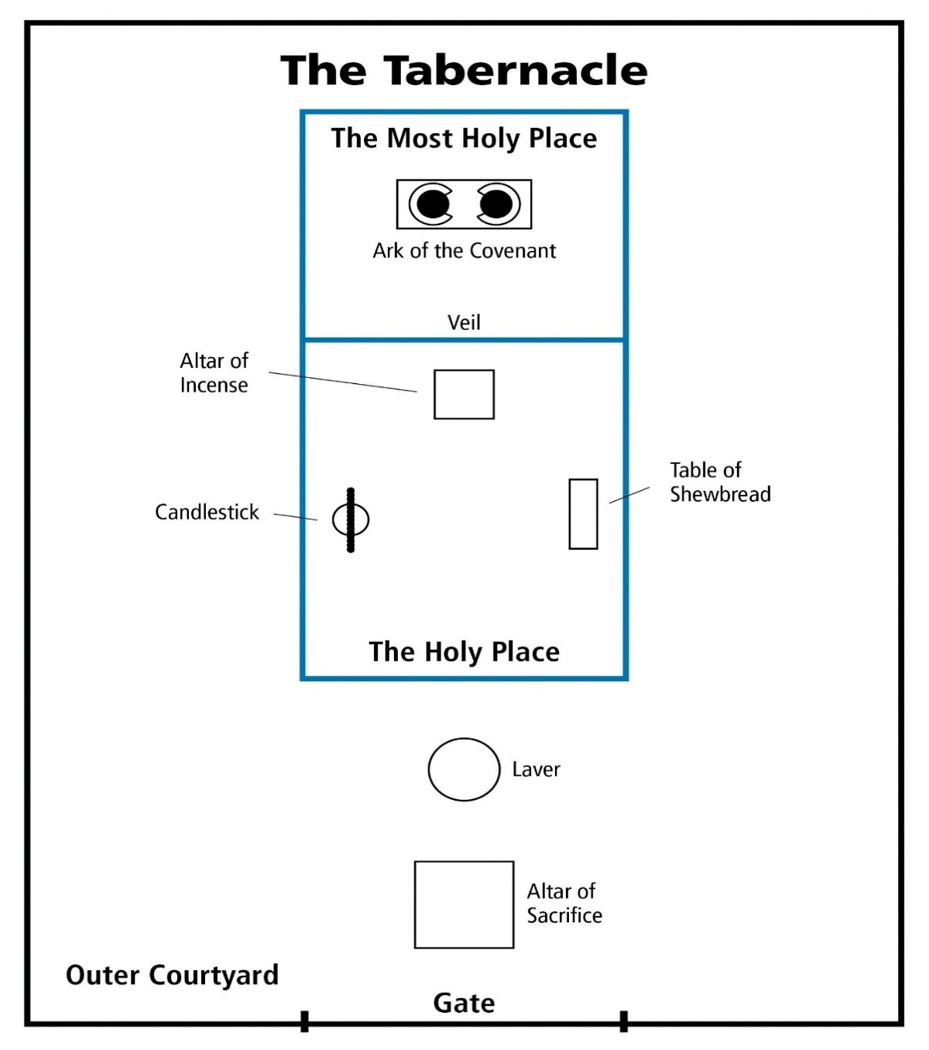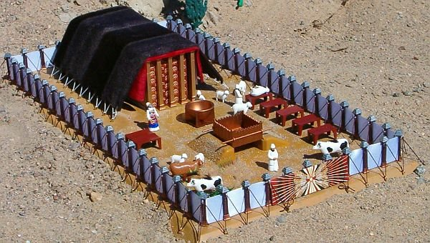

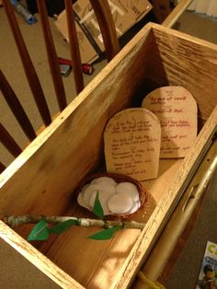

ARK – SYMBOL OF THE SON OF MAN.

55-0522 THE.ARK_ JEFFERSONVILLE.IN V-26 N-18 SUNDAY_
Now, watch the ark of the covenant. He said, "You shall make it out of acacia wood and overlay it with gold." Anyone who knows the Scripture, know that gold speaks of Deity, and wood speaks of humanity. See He said, "You shall cover it, overlay it with gold, over the wood." That's Deity over the wood: Christ over the Church, inside and out, Deity, overlaid.
« 137 † You'll have a lid on top of it. It'll be a mercy seat, and all the laws will rest in it. But before you...?... you sprinkle it over with blood. The law speaks of judgment. But between the law and the congregation, there was something for Deity stood in its place: type of Christ. Between the wrath of God, the judgment in hell, between that and the believer stands Deity Himself, Christ, standing in the way with an atonement made to save us from our sins and to heal us from our sickness. Deity stands in the way between judgment.

61-0101 REVELATION.CHAPTER.FOUR.2_ JEFFERSONVILLE.IN ROJC 585-643 SUNDAY_
« 228 † There you are! Your daily walk, your daily talk, your daily behavior, your heart, your soul, and all, "Holy, holy, holy, unto the Lord." No roots of bitterness, no nothing else, "Holy, holy, holy, unto the Lord. Holy, holy, holy, unto the Lord," as we begin to approach in behalf of our brother. Whosoever will may come, anointed, Blood in front of him, the Blood going before him, playing "Holy, holy, holy, unto the Lord."
Now, that was the outer courts, the holy place. And the Holiest of holies, that was God's sanctuary on earth.

FRUITS

» NUMBERS 17
NUMBERS 17:1
» 7 † And Moses laid up the rods before the LORD in the tabernacle of witness.
» 8 † ¶ And it came to pass, that on the morrow Moses went into the tabernacle of witness; and, behold, the rod of Aaron for the house of Levi was budded, and brought forth buds, and bloomed blossoms, and yielded almonds.
» 9 † And Moses brought out all the rods from before the LORD unto all the children of Israel: and they looked, and took every man his rod
» 10 † And the LORD said unto Moses, Bring Aaron's rod again before the testimony, to be kept for a token against the rebels; and thou shalt quite take away their murmurings from me, that they die not.

JOHN 12:23
» 23 † And Jesus answered them, saying, The hour is come, that the Son of man should be glorified.
» 24 † Verily, verily, I say unto you, Except a corn of wheat fall into the ground and die, it abideth alone: but if it die, it bringeth forth much fruit.

MATTHEW 15:13
» 13 † But he answered and said, Every plant, which my heavenly Father hath not planted, shall be rooted up.

ROMANS 6:4
» 4 † Therefore we are buried with him by baptism into death: that like as Christ was raised up from the dead by the glory of the Father, even so we also should walk in newness of life.
» 5 † For if we have been planted together in the likeness of his death, we shall be also in the likeness of his resurrection:
» 6 † Knowing this, that our old man is crucified with him, that the body of sin might be destroyed, that henceforth we should not serve sin.
» 7 † For he that is dead is freed from sin.

55-1007 THE.POWER.OF.DECISION_ CHICAGO.IL FRIDAY_
« E-28 † Put Aaron's rod in there, an old dead almond tree. But as it went under the Shekinah Glory, everything it was, was restored again. That's the way a sinner is when he goes under the Shekinah Glory of the Holy Spirit, the veils drop behind him, everything that he ought to have been, a son of God blooms out in him again. Amen.
Remember, overnight it budded, blossomed, and growed almonds on it, fruits of the Spirit: love, joy, long-suffering, goodness, gentleness, patience. That's what we need to get in the third step, get over into the Shekinah Glory where that little sacred Light was hanging over the--the mercy seat.

56-0101 WHY.ARE.PEOPLE.SO.TOSSED.ABOUT_ JEFFERSONVILLE.IN V-2 N-14 SUNDAY_
« 20-3 † And now, after they left that second court, sanctification, they entered into this consecrated life, entered into the Presence of God. And while they were in there, there's where they had all these glorious things. What a very beautiful type that in there, anything dead come in, lived again. Did you ever think of that? They took Aaron's rod and laid Aaron's rod in the presence of this holy place; and when they did, in one night's time it budded, blossomed, and yielded almonds: in one night's time. Think of it. In the Presence of God this old dead rod, lying there in the Presence of God budded, blossomed, and yielded almonds in one night. What was it then? What kind of a rod was it? It was an almond tree rod. That's what he taken it from; the stick was off of an almond tree. And you are a stick some kind; and you're--you was taken off the branch of humanity, which was God's created son in the beginning. You may be fallen, dead, alienated from God; but by that in creation, you were created to be a son of God. You may bounce around, and be respected and honored out here in the courts, but if you ever get into that glorious place and hid away with God, you'll yield what you're supposed to do.

55-1110 A.HIDDEN.LIFE.IN.CHRIST_ SAN.FERNANDO.CA THURSDAY_
« E-25 † Notice, every year the high priest entered into that place. The congregation followed him up. And when he went into this great place where the veil dropped behind him, the inner courts, the holiest of holies, no one dared to go after him. Then he was alone with God.
What a beautiful picture it is today of a consecrated life who, once enters into with Christ, dead to the things of the world, hid away with God, and the veil's dropped down around, and all the world's shut off. Then Christianity and religion becomes a pleasure to every believer.
Today people just have enough religion to make them miserable, knowing that they ought to do this, they're trying to escape hell. Well, if that's the way I felt about it, brother, I don't know what I would do.
Oh, get in with Christ. Shut off from the things of the world, for, to commune with Him is a pleasure. It's beautiful. It's something that fills and satisfies the soul, something that gives you peace that passes all understanding. All the crosses become flying wings. All the burdens are chariot wheels. Oh, you can fly away.

Now, as... He can let that Spirit grow and take out all the roots of bitterness, and press God's way through him again; he can become back in the same condition that he was when he was in the garden of Eden. Jesus said in Mark 11:24: "Verily, verily, I say unto you, if you say to this mountain, 'Be moved,' and don't doubt in your heart, but believe that what you have said will come to pass, you can have what you said." That puts him right back supreme again. It puts him right back in the condition.

62-1014M THE.STATURE.OF.A.PERFECT.MAN_ JEFFERSONVILLE.IN V-2 N-18 SUNDAY_
« 350 † If you die, you take the blood out of a man, you embalm him. Trouble of it is, a lot of them never got embalmed. You take the blood out of the man, he's gone. Then the only thing you do is put another blood back in him; he's going to live again. You took his blood out.
351 And now we've put the Blood of Jesus Christ in, see, and that brings the faith of Jesus Christ, the virtue of Jesus Christ, the knowledge of Jesus Christ, the temperance of Jesus Christ, the patience of Jesus Christ, the godliness of Jesus Christ, the brotherly kindness of Jesus Christ, and the love of God, which is Jesus Christ. He's the Head and controls you. And your feet is the foundation, faith. Amen! Controlled by the Head, takes the...?... There you are. There is the perfect man of God, when he possesses these virtues.
CHARTS
ENEMIES OF THE CROSS, GET TO THE CROSS AND THEN CARRY YOUR CROSS.

The Process
Based on Roman literature as well as descriptions in the provinces, crucifixion was an established routine. There were special military teams led by a centurion, and in the provinces, the soldiers were selected from the local auxiliaries (natives who had joined the Roman army). The victim was stripped and then lashed (scourged). As part of the public humiliation, he/she was led through the streets and remained naked. Christian art portrays Jesus with a decent loincloth on the cross, but the nakedness was maintained as part of the humiliation. There was a public plaque (titulus) indicating the crime. The shedding of blood and the concept of corpse contamination meant that the executions took place outside the city walls. The most popular spot was along one of the main roads leading into the city. This also served as propaganda purposes to demonstrate Roman law and order.
THE VICTIM DID NOT CARRY THE WHOLE CROSS, BUT ONLY THE CROSS-BEAM.
These killing fields contained permanent, upright poles. The victim did not carry the whole cross, but only the cross-beam. The combined pole and cross-beam weighed approximately 135-180 kg (300-400 pounds). After scourging (the trauma and the loss of blood), there was a risk that the victim could die before arriving at the site of execution. The necessity of keeping the victim alive led to the practice of the legions commandeering someone from the crowd to help carry the beam when the victim succumbed. This is the role of Simon of Cyrene in the gospel versions.
Upon arrival, the victim was either tied or nailed to the cross-beam which was then hoisted up and connected to the vertical pole (with ladders and pulleys). We have evidence of the use of nails from several sources. These were 13-18 cm (5-7 in) long tapered iron spikes. The application of the nails varied. Seneca reported that some were hung upside down, or with arms stretched out on either side. Josephus reported seeing crucifixion victims at the siege of Jerusalem (70 CE) where the soldiers positioned them in various poses to amuse themselves out of anger and hatred. Some people collected the nails as magical amulets.

PHILIPPIANS 3:18
» 18 † (For many walk, of whom I have told you often, and now tell you even weeping, that they are the enemies of the cross of Christ:
» 19 † Whose end is destruction, whose God is their belly, and whose glory is in their shame, who mind earthly things.)

COLOSSIANS 2:14
» 14 † Blotting out the handwriting of ordinances that was against us, which was contrary to us, and took it out of the way, nailing it to his cross;

I CORINTHIANS 1:17
» 17 † ¶ For Christ sent me not to baptize, but to preach the gospel: not with wisdom of words, lest the cross of Christ should be made of none effect.
» 18 † For the preaching of the cross is to them that perish foolishness; but unto us which are saved it is the power of God.

MATTHEW 10:37
» 37 † He that loveth father or mother more than me is not worthy of me: and he that loveth son or daughter more than me is not worthy of me.
» 38 † And he that taketh not his cross, and followeth after me, is not worthy of me.
» 39 † He that findeth his life shall lose it: and he that loseth his life for my sake shall find it.

MATTHEW 16:24
» 24 † ¶ Then said Jesus unto his disciples, If any man will come after me, let him deny himself, and take up his cross, and follow me.
» 25 † For whosoever will save his life shall lose it: and whosoever will lose his life for my sake shall find it.

MARK 8:34
» 34 † And when he had called the people unto him with his disciples also, he said unto them, Whosoever will come after me, let him deny himself, and take up his cross, and follow me.

LUKE 9:23
» 23 † And he said to them all, If any man will come after me, let him deny himself, and take up his cross daily, and follow me.
» 24 † For whosoever will save his life shall lose it: but whosoever will lose his life for my sake, the same shall save it.

LUKE 14:27
» 27 † And whosoever doth not bear his cross, and come after me, cannot be my disciple.

HEBREWS 12:1
» 1 † ¶ Wherefore seeing we also are compassed about with so great a cloud of witnesses, let us lay aside every weight, and the sin which doth so easily beset us, and let us run with patience the race that is set before us,
» 2 † Looking unto Jesus the author and finisher of our faith; who for the joy that was set before him endured the cross, despising the shame, and is set down at the right hand of the throne of God.
A POSITION !!!!

