WHO IS THIS SON OF MAN ?
PART 54

54-1024 THE.UNPARDONABLE.SIN_ JEFFERSONVILLE.IN V-26 N-8 SUNDAY_
« 79 † We went through it this morning. Now, the water... "Sprinkled" there means "shook away," our conscience, with the sin problem, evil and darkness shook off of it. And with our bodies washed with pure water, through water baptism in the Name of Jesus Christ, walk freely and boldly up to God, knowing this, that "The evil that I once loved has passed away, knowing that the life that I once lived is now ceased. Not because I did it; because Something come in me and did it Itself. By grace He saved me. I believed Him. He give me the Holy Spirit. The things that I once hated, I now love. The sacrifice, it used to be hard for me to go to church; I love to go now. To hear the people sing and shout and testify, I used to hate it; I love it now. Something has changed me. Then I have a new and living way. Something has anchored here. I know when I went down into the water and they baptized me into the Name of the Lord Jesus Christ..."
He said, "Repent, and be baptized every one of you in the Name of Jesus Christ for the remission of your sins, and you shall receive the gift of the Holy Ghost."
« 82 † I've been argued at, fussed at, run down, made fun of, don't make a bit of difference. God said so, and I believe it.

JOHN 1:1 & 14
» 1 † ¶ In the beginning was the Word, and the Word was with God, and the Word was God.
» 14 † And the Word was made flesh, and dwelt among us, (and we beheld his glory, the glory as of the only begotten of the Father,) full of grace and truth.

I THESSALONIANS 4:4
» 4 † That every one of you should know how to possess his vessel in sanctification and honour;

ROMANS 12:2
» 2 † And be not conformed to this world: but be ye transformed by the renewing of your mind, that ye may prove what is that good, and acceptable, and perfect, will of God.

HEBREWS 4:15
» 15 † For we have not an high priest which cannot be touched with the feeling of our infirmities; but was in all points tempted like as we are, yet without sin.
» 16 † Let us therefore come boldly unto the throne of grace, that we may obtain mercy, and find grace to help in time of need.

FIRST STAGE – THE BIRTH

ROMANS 8:14-17
» 14 † For as many as are led by the Spirit of God, they are the sons of God.
» 15 † For ye have not received the spirit of bondage again to fear; but ye have received the Spirit of adoption, whereby we cry, Abba, Father.
» 16 † The Spirit itself beareth witness with our spirit, that we are the children of God:
» 17 † ¶ And if children, then heirs; heirs of God, and joint-heirs with Christ; if so be that we suffer with him, that we may be also glorified together.

JUSTIFICATION

SANCTIFICATION - soul
- 55-1110 A.HIDDEN.LIFE.IN.CHRIST
He said He'd give you a new spirit. Now, that spirit isn't God's spirit; that's your spirit. God gives you a new spirit, then He says, "I'll put my Spirit in him." But the thing God has to do is give you a new spirit, make your nature a little more gentle and settle down, or He couldn't even live with you.

BAPTISM OF THE HOLY GHOST
I PETER 1:22-25
» 22 † Seeing ye have purified your souls in obeying the truth through the Spirit unto unfeigned love of the brethren, see that ye love one another with a pure heart fervently:
» 23 † Being born again, not of corruptible seed, but of incorruptible, by the word of God, which liveth and abideth for ever.

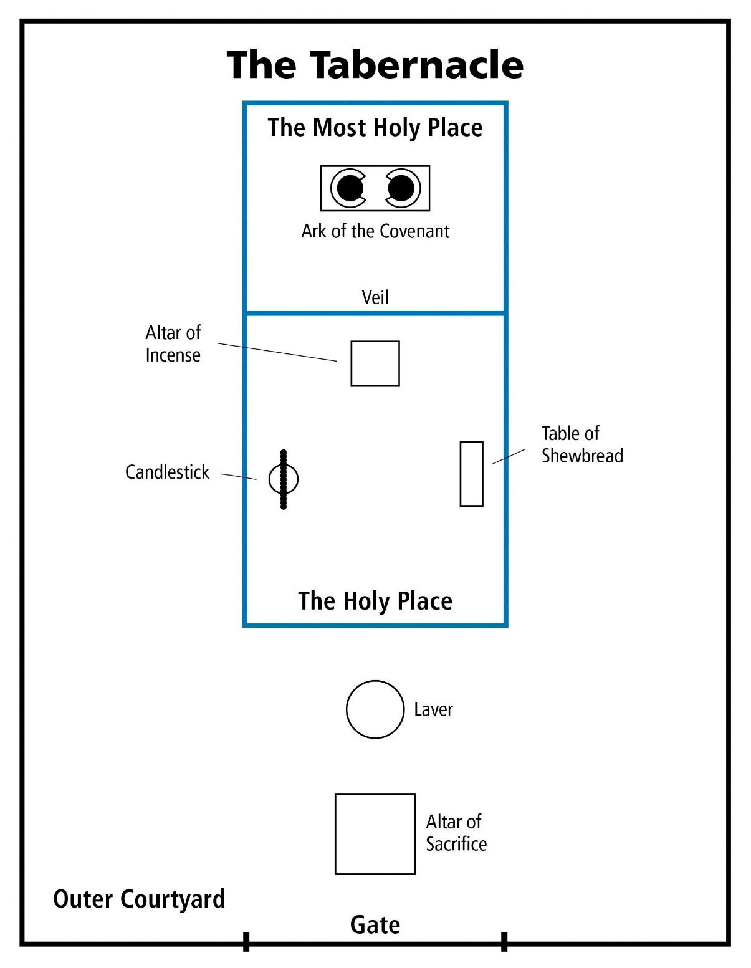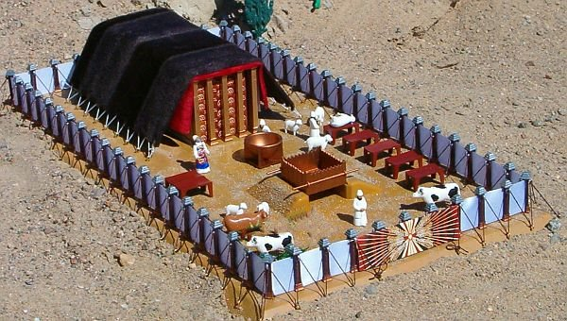

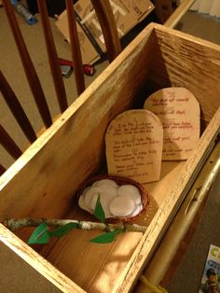

61-0101 REVELATION.CHAPTER.FOUR.2_ JEFFERSONVILLE.IN ROJC 585-643 SUNDAY_
« 222 † Now, notice these holy places. Now, when you come into the courts, the first was the courts, the outer courts. The next was the altar, where the sacrifices was offered, the brazen altar. Then outside of the brazen altar, there was a veil hung here that went into the Holy of holies; in there was the mercy seat, in there was the Cherubims. That's what I want to get to in our next lesson, those Cherubims overshadowing the mercy seat. Oh, my! I... We can just stay all month on it, see, on that Cherubim.
« 223 † Now, now notice as they entered in. The congregation could come there; the priests could stand here; but just the high priest could go in there, once a year, taking the blood with him.
And he had to be dressed a certain way, a certain garment; had to have a bell and a pomegranate, one to one another. And when he walked, he had to walk a certain way. As he walked, he played, "Holy, holy, holy, unto the Lord. Holy, holy, holy, unto the Lord," those bells and pomegranates ringing together, "Holy, holy, holy!" Why? He was approaching God, having the blood of the covenant in his hand, going before Him, bearing the blood.
Anointed (Oh, my!) with certain perfumes. His clothes had to be made by Holy Ghost-filled hand, registered hands make his clothes. The rose of Sharon, the anointing oil, poured it on his head, it run all down his beard and then down over. He was placing the royal perfume; a pomegranate and a bell; taking the blood of an innocent lamb; and he daresn't approach that veil outside... he'd die right where he was standing. So he had to go, walking a certain way, "Holy, holy, holy, unto the Lord. Holy, holy, holy," (approaching God) "unto the Lord. Holy, holy, holy!"
« 226 † And he went there and offered the blood on the mercy seat, once a year. And while he was in there, he was privileged to see the Shekinah Glory; when the Pillar of Fire, the amber Light that come down, that led the children out of Israel. He even smoked up the temple so no one could see It. The Glory of the Lord fell till it was all smoked up. And He came in Hisself, went in behind the veil and settled down on the mercy seat in the Holiest of holies. "Most Holy place," it's called, Holy of holies. And he had to be dressed a certain way, walk a certain way, anointed a certain way. He was a special person to go in there. How the congregation must have envied him!
But when Jesus died, the temple veil rent. Not only a high priest, but "whosoever will" can have that same anointing of the Shekinah Glory and walk a holy life, "Holy, holy, holy, unto the Lord," and approach in the very Presence of God, through the Blood of Jesus Christ before him. Take him with: "Lord Jesus, here lays a sick man, he's my brother. He's on the deathbed right now, to die. I'm approaching You, 'Holy, holy, holy, unto the Lord.'"
"What for?"
"As a high priest."
"What for?"
"In behalf of my brother. 'Holy, holy, holy, unto the Lord.'"
« 228 † There you are! Your daily walk, your daily talk, your daily behavior, your heart, your soul, and all, "Holy, holy, holy, unto the Lord." No roots of bitterness, no nothing else, "Holy, holy, holy, unto the Lord. Holy, holy, holy, unto the Lord," as we begin to approach in behalf of our brother. Whosoever will may come, anointed, Blood in front of him, the Blood going before him, playing "Holy, holy, holy, unto the Lord."
Now, that was the outer courts, the holy place. And the Holiest of holies, that was God's sanctuary on earth.

FRUITS

» NUMBERS 17
NUMBERS 17:1
» 1 † ¶ And the LORD spake unto Moses, saying,
» 2 † Speak unto the children of Israel, and take of every one of them a rod according to the house of their fathers, of all their princes according to the house of their fathers twelve rods: write thou every man's name upon his rod.
» 3 † And thou shalt write Aaron's name upon the rod of Levi: for one rod shall be for the head of the house of their fathers.
» 4 † And thou shalt lay them up in the tabernacle of the congregation before the testimony, where I will meet with you.
» 5 † And it shall come to pass, that the man's rod, whom I shall choose, shall blossom: and I will make to cease from me the murmurings of the children of Israel, whereby they murmur against you.
» 6 † And Moses spake unto the children of Israel, and every one of their princes gave him a rod apiece, for each prince one, according to their fathers' houses, even twelve rods: and the rod of Aaron was among their rods.
» 7 † And Moses laid up the rods before the LORD in the tabernacle of witness.
» 8 † ¶ And it came to pass, that on the morrow Moses went into the tabernacle of witness; and, behold, the rod of Aaron for the house of Levi was budded, and brought forth buds, and bloomed blossoms, and yielded almonds.
» 9 † And Moses brought out all the rods from before the LORD unto all the children of Israel: and they looked, and took every man his rod
» 10 † And the LORD said unto Moses, Bring Aaron's rod again before the testimony, to be kept for a token against the rebels; and thou shalt quite take away their murmurings from me, that they die not.

HEBREWS 4:15
» 15 † For we have not an high priest which cannot be touched with the feeling of our infirmities; but was in all points tempted like as we are, yet without sin.
» 16 † Let us therefore come boldly unto the throne of grace, that we may obtain mercy, and find grace to help in time of need.

55-1110 A.HIDDEN.LIFE.IN.CHRIST_ SAN.FERNANDO.CA THURSDAY_
« E-25 † Notice, every year the high priest entered into that place. The congregation followed him up. And when he went into this great place where the veil dropped behind him, the inner courts, the holiest of holies, no one dared to go after him. Then he was alone with God.
What a beautiful picture it is today of a consecrated life who, once enters into with Christ, dead to the things of the world, hid away with God, and the veil's dropped down around, and all the world's shut off. Then Christianity and religion becomes a pleasure to every believer.
Today people just have enough religion to make them miserable, knowing that they ought to do this, they're trying to escape hell. Well, if that's the way I felt about it, brother, I don't know what I would do.
Oh, get in with Christ. Shut off from the things of the world, for, to commune with Him is a pleasure. It's beautiful. It's something that fills and satisfies the soul, something that gives you peace that passes all understanding. All the crosses become flying wings. All the burdens are chariot wheels. Oh, you can fly away.

61-0117 THE.MESSIAH_ SHREVEPORT.LA TUESDAY_
« E-18 † Now, for instances when a man gets saved, he's just about like... The Light that comes into him is about like this little white button on my shirt. That's when God comes into the inner part of a man. In the inner part of a man or... A man is made up in the system of a tabernacle: in the outer courts, then holy place, and the holiest of holies; the Shekinah glory on the inside, the veil.
Now, on the outside gates of a man is his five senses that enters to his body. On the inside, which is his soul, or the... The--the soul is the nature of the spirit that's on the inside of his heart; produces his soul, which makes the atmosphere around him. He has also five entrances.
Then on the inside he has only one gate, one entrance to go into the Shekinah glory, where God can enter into him and take over in the control tower. And that way is through self-will. Whether you will to or not, that's up to you. But that's the only avenue that's open to the man that God can come into his heart, is by self-will. Puts him right back like Adam and Eve on free moral agency again. You can choose right or wrong, either one you want to.
« E-19 † Now, self-will... Then God comes into the man, into the heart, which is the spirit. Then the spirit makes the soul, and then the soul dwells in the body. Now, when a man is converted, say, just like that little white button starts in his heart. Now, that part is God. God... When he's born again with the Spirit of God, God's Spirit dwells in him.
Now, as... He can let that Spirit grow and take out all the roots of bitterness, and press God's way through him again; he can become back in the same condition that he was when he was in the garden of Eden. Jesus said in Mark 11:24: "Verily, verily, I say unto you, if you say to this mountain, 'Be moved,' and don't doubt in your heart, but believe that what you have said will come to pass, you can have what you said." That puts him right back supreme again. It puts him right back in the condition.

62-1014M THE.STATURE.OF.A.PERFECT.MAN_ JEFFERSONVILLE.IN V-2 N-18 SUNDAY_
« 350 † If you die, you take the blood out of a man, you embalm him. Trouble of it is, a lot of them never got embalmed. You take the blood out of the man, he's gone. Then the only thing you do is put another blood back in him; he's going to live again. You took his blood out.
351 And now we've put the Blood of Jesus Christ in, see, and that brings the faith of Jesus Christ, the virtue of Jesus Christ, the knowledge of Jesus Christ, the temperance of Jesus Christ, the patience of Jesus Christ, the godliness of Jesus Christ, the brotherly kindness of Jesus Christ, and the love of God, which is Jesus Christ. He's the Head and controls you. And your feet is the foundation, faith. Amen! Controlled by the Head, takes the...?... There you are. There is the perfect man of God, when he possesses these virtues.

