Notes used in the Message
www.SpokenWordChurch.com
19-0630am - Salvation Pt.15 (Stage 2&3 Pt.1)- Samuel Dale

EPHESIANS 2:8
» 8 † For by grace are ye saved through faith; and that not of yourselves: it is the gift of God:

EZEKIEL 36:24-27
» 24 † For I will take you from among the heathen, and gather you out of all countries, and will bring you into your own land.
» 25 † ¶ Then will I sprinkle clean water upon you, and ye shall be clean: from all your filthiness, and from all your idols, will I cleanse you.
» 26 † A new heart also will I give you, and a new spirit will I put within you: and I will take away the stony heart out of your flesh, and I will give you an heart of flesh.
» 27 † And I will put my spirit within you, and cause you to walk in my statutes, and ye shall keep my judgments, and do them.

1) 64-0802 THE.FUTURE.HOME.OF.THE.HEAVENLY.BRIDEGROOM.AND.THE.EARTHLY.BRIDE_ JEFFERSONVILLE.IN V-3 N-5 SUNDAY_
« 87 † Now, the first step is "repentance towards God." And then follows after that, is water baptism, "water baptism," "Repent, and be baptized in the Name of Jesus Christ." See, water baptism follows, showing that repentance was genuine. Or, to "remit" our past sins, that has nothing to do with future sin. It only remits. "Repent, and be baptized in the Name of Jesus Christ." What for? "Remission." Taking away of past sin has nothing to do with the future. Just, your sin has been chopped off, what you did.
88 You can't repent for what Adam done. You never done it; Adam did. You just get forgiveness for what you done. The old nature is still there.

« 89 † Let me take this board just a minute. [Brother Branham draws illustrations on the blackboard--Ed.] Now, here is a human heart. Now, I'm not... I'm a long ways from being an artist. Here is a human heart; and here is a human heart. Now, this one over here has a snake in it, that's sin, here he has his life. This one over here has a dove in it, which is the Holy Spirit, here he has a Life. Well, this one here, he has malice, hatred, envy; that's what's causing it, is this fellow here. Well, this one over here has love, and joy, and long-suffering; and That's what does it, down here.
90 Now, when you are asked, or you are forgiven of your sins, you've only done this, taken that away. But the thing that made you do it is still there. That's the old root of evil; it's still there. Notice, then you repent and are baptized in the Name of Jesus Christ, that He forgave you of your sins. Notice.

« 91 † Then, secondly, comes sanctification, which sets our mind in order for holiness, to think right. Taken away... sanctification is a compound Greek word, which means "cleaned, and set aside for service."
92 Then, the next, comes the baptism of the Fire and Holy Ghost, that God might dwell in us. And the Fire of God cleanses our hearts from sin, and puts the Holy Ghost inside. Then we bring forth the same Life that This did, because That's in us.

2) HEBREWS 10:22-23
» 22 † Let us draw near with a true heart in full assurance of faith, having our hearts sprinkled from an evil conscience, and our bodies washed with pure water.
» 23 † Let us hold fast the profession of our faith without wavering; (for he is faithful that promised;)

3) EPHESIANS 5:24-27
» 24 † Therefore as the church is subject unto Christ, so let the wives be to their own husbands in every thing.
» 25 † Husbands, love your wives, even as Christ also loved the church, and gave himself for it;
» 26 † That he might sanctify and cleanse it with the washing of water by the word,
» 27 † That he might present it to himself a glorious church, not having spot, or wrinkle, or any such thing; but that it should be holy and without blemish.

4) 65-0815 AND.KNOWETH.IT.NOT_ JEFFERSONVILLE.IN V-2 N-10 SUNDAY_
« 120 † Now, now that, the Church, that His very whole purpose was the Church. Now how do we get into this Church? "By one Spirit we're all baptized into one Body," the Church, the Body of Christ. It cannot fail.
121 Now, here is what happens. Now watch this, just a little figurative picture here. [Brother Branham again shows his drawing of three rings--Ed.]
122 Now, this outside man is the flesh. That's what we look at; what we see. And it has five inlets to that body. And any grammar school child, as myself, would know there is five senses control the body; see, taste, feel, smell, and hear. Without that, you can't touch the body. That's the only way you have to the body; see, taste, feel, smell, hear; you see it, taste it, feel it... Now, that is the evil one, on the outside.

« 123 † Now, inside of that is a spirit, which you become when you're born in the earth and the breath of life is breathed into him. That spirit is of a worldly nature because it was not given from God, but it was (given) permitted by God. Now you got that? For, every child that's born in the world, "is born in sin, shaped in iniquity; come to the world speaking lies." That right? So, that person, inside there, is a sinner, to begin with. Now, but...
124 Now, it's got five inlets. And them five inlets... I don't know whether I can call them right off now. When the... First, I know, is thought, conscience, and love, choice... No. Conscience, love, reason... There is five inlets to the spirit. You can't think with your body; you have to think with your spirit. You can't have conscience in your body. It has no mental faculties at all; your body doesn't, so you have to think with your spirit. You have to reason. You can't reason with your physical being, 'cause reason doesn't see, taste, feel, smell, or hear. Reason is what you can make in your mind. If you're asleep or you're out, your body is lying there dead, but your spirit can still reason. There is five senses that controls that inside man. And that...
125 Now, to the last man, which is the soul, there is only one sense that controls that, and that is free... moral agency's free will to choose or to reject.

« 126 † And now the reason that people today... Now, don't forget this now, and you'll--you'll see what the Holy... what the initial evidence of the Holy Ghost is. See?
127 Now, people can live in this spirit, and they dance in the spirit. They shout in the spirit. They go to church in the spirit, and they can absolutely have the real Spirit of God anointed on that spirit, but still be lost and just as devil-possessed as they can be, with that spirit.
128 Because, watch, that's the reason you couldn't tell that woman, she was wearing shorts, was wrong. You couldn't tell her bobbing her hair was wrong. "Well, what's your hair got to do with it?" Well, it did to Samson. See?
129 "Whosoever shall add one word to This, or take one Word from It." You've got to have an ultimate somewhere.

5A)55-0806 JESUS.CHRIST.THE.SAME.YESTERDAY.TODAY.AND.FOREVER_ CAMPBELLSVILLE.KY SATURDAY_
« E-17 † Now, there is two elements, just for a few moments on this subject. There's two elements that make up the human being. And one of them is your mind, and the other is your soul. And the mind is your mental thinking, your intellectual. And your soul is a part of God that's in you.
Now, now a man can... When you are borned in this world you be... As a child, you grow into be a living soul and at the age of choice, you hear the Gospel in some way, and something way down inside you tells you to receive Christ. That... You'll say, "Well, I'm too young now. I'll wait a little longer." Now, there's where you make your first mistake right there, for you grieved this person inside. God's not going to judge you by this man up here, your intellect. He's going judge you by your soul.

5B)52-0224 BELIEVING.GOD_ JEFFERSONVILLE.IN V-19 N-7 SUNDAY_
« 199 † Now, hallelujah, here it is. No wonder that God would never let a true man of God ever say he could heal somebody. Christ done that when He died. I couldn't save nobody, or no one else can save anybody, but God.
And God can't save you, because He's already done it. The only thing you have to do is accept it. It's already done. I wasn't saved twenty years ago; I was saved nineteen hundred years ago. But twenty years ago I received it and accepted it. If it hadn't, the first sin I done, God would've wiped me off the face of the earth; 'cause He said He would, and He has to keep His promise. I was healed nineteen hundred years ago, but I've got to accept it.

« 201 † And the only thing that kept me from being saved when I was twelve years old, because a spirit hung over me, a devil, saying, "Wait a little while longer." That's the reason you wasn't saved when you become the age of accountability. A spirit, you got with a crowd, and that hovered over you and kept hanging over you. You wanted to do right. There's not a man that's got his right mind but what wants to do right, but there's something won't let you do right. Is that right? That's the devil. Hallelujah. Christ paid your healing and your salvation.

5) EZEKIEL 11:19-21
» 19 † And I will give them one heart, and I will put a new spirit within you; and I will take the stony heart out of their flesh, and will give them an heart of flesh:
» 20 † That they may walk in my statutes, and keep mine ordinances, and do them: and they shall be my people, and I will be their God.
» 21 † But as for them whose heart walketh after the heart of their detestable things and their abominations, I will recompense their way upon their own heads, saith the Lord GOD.

6) EZEKIEL 18:31
» 31 † Cast away from you all your transgressions, whereby ye have transgressed; and make you a new heart and a new spirit: for why will ye die, O house of Israel?

7) EZEKIEL 36:23-28
» 23 † And I will sanctify my great name, which was profaned among the heathen, which ye have profaned in the midst of them; and the heathen shall know that I am the LORD, saith the Lord GOD, when I shall be sanctified in you before their eyes.

» 24 † For I will take you from among the heathen, and gather you out of all countries, and will bring you into your own land.
» 25 † ¶ Then will I sprinkle clean water upon you, and ye shall be clean: from all your filthiness, and from all your idols, will I cleanse you.
» 26 † A new heart also will I give you, and a new spirit will I put within you: and I will take away the stony heart out of your flesh, and I will give you an heart of flesh.
» 27 † And I will put my spirit within you, and cause you to walk in my statutes, and ye shall keep my judgments, and do them.
» 28 † And ye shall dwell in the land that I gave to your fathers; and ye shall be my people, and I will be your God.

8) GENESIS 2:7
» 7 † And the LORD God formed man of the dust of the ground, and breathed into his nostrils the breath of life; and man became a living soul.

9) I CORINTHIANS 15:45
» 45 † And so it is written, The first man Adam was made a living soul; the last Adam was made a quickening spirit.

10) 55-1111 WHERE.I.THINK.PENTECOST.FAILED_ SAN.FERNANDO.CA FRIDAY_
« E-23 † Now, where I think it is, friend, Christian friend, is first... There's two things that we have to watch closely. One of them is an intellectual religion, intellectual faith. And the other one is a borned again experience. One of them is in the head, and the other one's in the heart.
Now, of course, science has fought against that up till last year. But in the Chicago paper, when I got it, I just screamed. You know the Bible said, "As a man thinketh in his heart, so is he." As a man thinketh in his heart...
Well now, science said, "God got all mixed up." Said, "Because there's no mental faculties in the heart to think with." It's just a pump, that pumps to the blood, purifying the blood, coming through the cylinder, as it was. But said, "The mental faculties is in the head." But, you know, they have to take that back now, and say God was right.
About a year ago they found out that in the human heart that there's a little compartment, teeny, that even a blood cell don't exist in. It's not in an animal heart; it's only in the human heart. And they found out that that's the occupied place of the soul. Did you ever have something that you just knowed was going to happen, yet you couldn't reason it out, but something just told you it was going to happen anyhow? You believe that in your heart. That's something down here.

11) 58-0326 UNITED.UNDER.ONE.HEAD_ MIDDLETOWN.OH WEDNESDAY_
« E-18 † Here sometime ago, years ago, the scientists said, "Well, God sure made a mistake there, because there is no mental faculties in the human heart to think with. Yeah, He meant your head." If God would've meant head, He'd have said head. But He said heart, so I believe He meant heart.
Then you know, about five years ago I was in Chicago. I seen a great piece in the headlines of the paper where that science had found that in the human heart, not the animal heart, in the human heart there's a little compartment that doesn't even have a blood cell in it. It was the abiding place of the soul. So man does think with his heart after all. God was right.

« E-19 † And we'll find out every time that God is right. He thinks with his head, but he believes in his heart. Now, the devil thinks through his mind to show him something with his eye. But his heart will make him believe something that would be impossible to look at, because it's the faith that he has in his heart. He believes with his heart for things that he can't see. And the devil turns around and takes his head and makes him scientifically prove something. And his heart turns around and denies it.
Oh, if we could get away from our head knowledge and head religion, to heart religion where God could go to work in the Church... Out of our head into our heart... A man believes in his heart. He thinks with his head, believes in his heart.
Now, the mind reasons things. The heart doesn't reason at all. It just believes what God says. But you see, today we're so scientific, oh, we Americans anyhow. We are so scientific; it has to be all proved out to us.

12) 56-0121 THE.INTER.VEIL_ STURGIS.MI SATURDAY_
« E-59 † God prophesied through the prophet and said, "I will write My laws in their hearts, where I put them, in the tables of their hearts." Showing that that would be the dwelling place of God in the human heart, not the human head, but the human heart. Amen. "I will write them in My heart--in their heart. And they'll keep My statutes, and so forth," saith the Lord.
God said in another place over in Ezekiel, He said, "I will in that day, take out your old fleshly, stony heart. And I'll give you a new spirit, and I'll put a--My Spirit in you."
Now, a lot of people, even you Pentecostal people, lot of times get mistaken in that. You get a new spirit; that's not God's Spirit; that's you. That isn't God. You get a little happy, because you got a new spirit and you jump up-and-down, run around over the floor, maybe, and shout a little bit, and speak with tongues, and run around a little bit and think you got the Holy Ghost. That's not it. That's a new spirit, God gave you. That's you. Then after He give you your spirit, then He said, "I'll put My Spirit..."
That's what's the matter with the miss-meal cramps you got today. That's right. That's the reason you can't get nowhere with God.

13) 57-0303A WHY.IS.IT.THAT.SO.MANY.CHRISTIANS.FIND.IT.SO.HARD.TO.LIVE.THE.CHRISTIAN.LIFE_ PHOENIX.AZ SUNDAY_
« E-31 † Notice, now, "I'll give you a new spirit, and I'll put My Spirit..." Notice, the new heart is put right in the middle of you. And the new spirit is put right in the middle of your new heart. And His Spirit is put right in the middle of the new spirit.
It's just like the mainspring in a famous watch. When that... When that mainspring sets in the middle of the watch, it controls every movement of that watch. And that's what's the matter, friends. Now, I hope you see this. And I'm not saying it to be--try to twist or be indifferent; I'm only saying it because I know that someday I'll stand in the judgment with you. You see, if the Holy Spirit is in the middle of your spirit... And that watch spring makes all the rest of the movements just tick just exactly to the place, keeping perfect time. When the Holy Spirit is in the middle of your spirit, it makes every action of the Holy Spirit in you tick off just exactly according to God's Timepiece, the Bible. Right.

14) 57-0324 WHY.SOME.PEOPLE.CAN'T.KEEP.THE.VICTORY_ OAKLAND.CA SUNDAY_
« E-50 † Yes. That's what we need today is experiences of the new birth. Now, I want you to watch the order that Ezekiel brought it in. He said, "I will give you a new heart, and I'll give you a new spirit, and I'll put My Spirit in you." I want you to watch; there's three of it. A new heart. "I'll take the old stony heart away." That's that old different heart you have. "And I'll give you a new spirit." Now, many times, and there's been a terrible mistake, the people has thought sometimes that that new spirit was the Holy Spirit. But it isn't; it's a new spirit. God gives you a new... Why, you couldn't even get along with yourself with your old spirit; how you going to get along with the Holy Ghost? God had to give you a new spirit so you could get along with His Spirit. And sometimes people...?... "A new heart, a heart of flesh, so you will receive it; then a new spirit in that heart, and then I'll put My Spirit in that." You see? New heart, new spirit, "and My Spirit," three things He spoke of.

« E-51 † Now, many times we try to make that thing just say... Well, as soon as you get the new spirit, you quit your stealing, you quit your lying, things like that. You say, "Oh, hallelujah, I got it." And you find out the first time anyone crosses your path a little bit, oh mercy, what a difference. Sure. You blow up like a frog eating buckshot. But let me tell you, brother. That's the reason you never got God's Spirit. That's true. "Oh," you say, "he stepped on my toe; I'll just not put up with that." All right. That shows what you got in you. That's true. "I'll put a new spirit in you, and then I'll put My Spirit in you."
Now, the heart is in the center of the emotions of the human being. Your heart is the middle of you. That's exactly right. So God puts a new heart in the middle of the old man, then He puts a new spirit in the middle of the new spirit, or heart, and puts His Spirit in the middle of the new spirit.

15) 57-0303A WHY.IS.IT.THAT.SO.MANY.CHRISTIANS.FIND.IT.SO.HARD.TO.LIVE.THE.CHRISTIAN.LIFE_ PHOENIX.AZ SUNDAY_
« E-28 † You get a new spirit; you quit your drinking. You get a new spirit you quit your drink--lying. You get a new spirit; you can do most anything with that spirit, but that isn't what God's talking about. "A new spirit," He said, "I'll give you..." Now watch, "I'll give you a new heart and a new spirit." Why, He'd have to give you a new spirit to live for Him.
Why, you couldn't even live with yourself with the spirit you did have. You couldn't live with your neighbor. You couldn't associate with the next man on the next corner. You couldn't associate with these Christians. Why, you'd have had an awful spirit. So He has to give you a new spirit. "I'll give you a new heart, a new spirit." Now, watch. "And I will put My Spirit in you." There's the difference. "I'll put My Spirit in you."
And there's where you find it so hard that you go down to church and you get a different concept. "You know what? I believe I ought to go to church."

« E-29 † Then you go back home and say, "Hallelujah, I got it." No you haven't. Then you go down to church and you say, "Oh, I believe that something's happened. I don't look at things the way I used to. Hallelujah!"
And in a few days you find yourself right down into the same old rut you was: doubting, reasoning, everything else. "Well now, if Pastor So-and-so said that wasn't right, I don't believe it's right. I'll just take his word for it. And I tell you I'm going to do this, and do that." And you find yourself up-and-down, and in-and-out. See, you just didn't go far enough.

« E-30 † Oh, you say, Brother Branham, I--I got all the evidences." I know, but we're not talking about evidences; we're talking about the product. That's right. Yes, sir. I've seen heathens shout. I've seen them speak with tongues. I've seen them lay down a pencil and write in unknown tongues, and a witch raise up and read it, interpret it and tell the truth.
If a man could speak with tongues, if a man could shout, if a man could see visions, if a man could do any of these other things that he can do without Divine love, they are lost. That's right. Christ is in the heart. See?
So don't be deceived by signs and evidences. There's all kinds of signs. The Bible said, in the last days false prophets will rise up and show such signs, it would deceive the very elect if possible. Come back to the Bible signs.

16) 57-0120M THE.IMPERSONATION.OF.CHRISTIANITY_ JEFFERSONVILLE.IN SUNDAY_
« 111 † They say, "Yes, sure I don't want to go to hell. I want to accept Christ." That's all right. That's good. That's just your first step.
Then He said after that, "Then I'll give you a new spirit."
What's that? A new desire, "I want to do right."
"Now, I know I'm a Christian, I got to... I'll smoke one more and then I'll throw it away. See? And I'll--I'll--I'll just see... I--I--I'll just stay home tonight, and you know, I'll just..." all these little just, just, that's exactly... Eve stopped just for a moment. That's all she had to do.
But now, that's the new spirit. Then notice the order of the Scripture. After you get a new heart and a new spirit, He said, "Then I'll put My Spirit..." See? Oh, what? That's the what the Scripture says here. That's the order, the numerics and numerical order of the Scripture: a new heart, a new spirit, and then My Spirit.

« 114 † Then God's Holy Spirit... God's new heart that He put in you, sets right in the center of you. That's your--your impulse, where you--you--your--your emotions goes out. And the new Spirit sets right in the center of the new heart. And God's Spirit, the Holy Spirit, sets right in the center of your new Spirit, and there It controls your emotions.
It's just like the--the mainspring in a famous watch, and it's self-winding. You don't have to wind it every day. God's wound it once for all. And it sets right in the middle of the--of your life--your new life. And as the mainspring, as it relieves and ticks away the watch, it controls every little organism of that watch to perfect time.

17) 57-0127A THE.IMPERSONATION.OF.CHRISTIANITY_ LIMA.OH SUNDAY_
« E-36 † Now, watch the Bible. "I'll give you--take the old stony heart away, and give you a heart of flesh, tender-hearted. And then I'll give you a new spirit. And then, I'll put My Spirit in you.
Now, watch. His Spirit was different from your new spirit. And many people gets the new spirit and think they get the Holy Spirit. They get feeling happy, and jump around, and maybe do a few things religiously. And they think that they got the Holy Spirit. Oh, no, the Holy Spirit makes you act different. The Holy Spirit makes you think different. The Holy Spirit was put right in the middle of your new spirit. And your new spirit was put right in the middle of your new heart. The new heart, the new spirit, in the middle of the new heart, and God said, "I will put My Spirit in you."
Now then, God's Spirit sets right in the middle of your spirit, your new spirit. And then you don't have to go out and act like Mrs. Jones does and like Mr. Jones does. There's just something in you; you just got the love of God so down in you, till you just live it. It isn't you; it's something in you.

18) 63-1110M SOULS.THAT.ARE.IN.PRISON.NOW_ JEFFERSONVILLE.IN V-2 N-22 SUNDAY_
« 36 † Now, the soul of man is not the body of man, it's the soul. See? And the soul is something that's the--the nature of the spirit. And then when the nature of a man... When he said, "We are dead," the Scripture plainly tells us that, "we are dead, and our lives are hid in God through Christ, sealed there by the Holy Spirit." Now, it wasn't that your body died; it wasn't your spirit died. It was the nature of your spirit died; see, the nature, which is the soul. The nature of your soul is--is God, if you're born again. If it's not, it's of the world. Anything that begin has to end, so therefore the only way that you can have Eternal Life is to have a Life that never did begin. And then your life did begin when you were born, when God breathed the breath of life into your nostrils and you became a living soul, then you begin then. But when you...
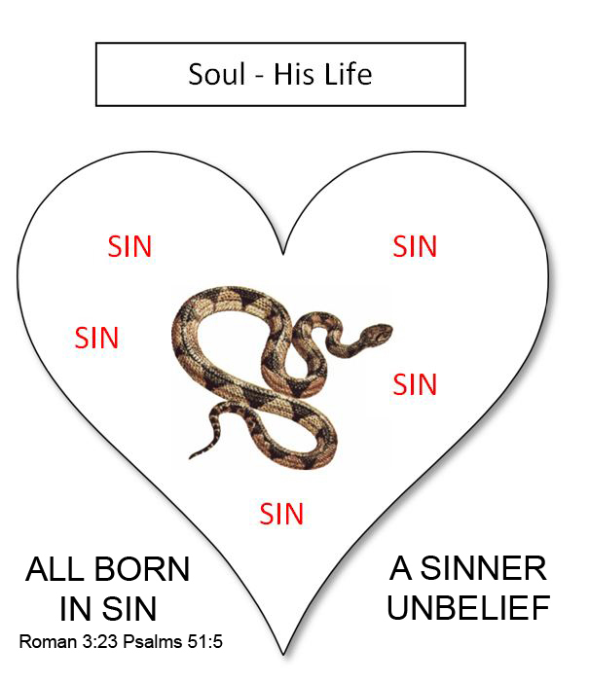

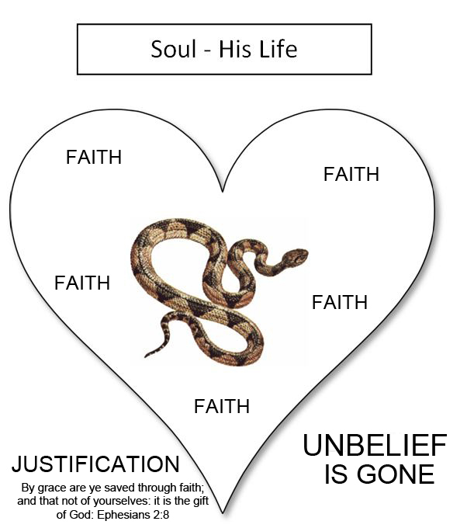

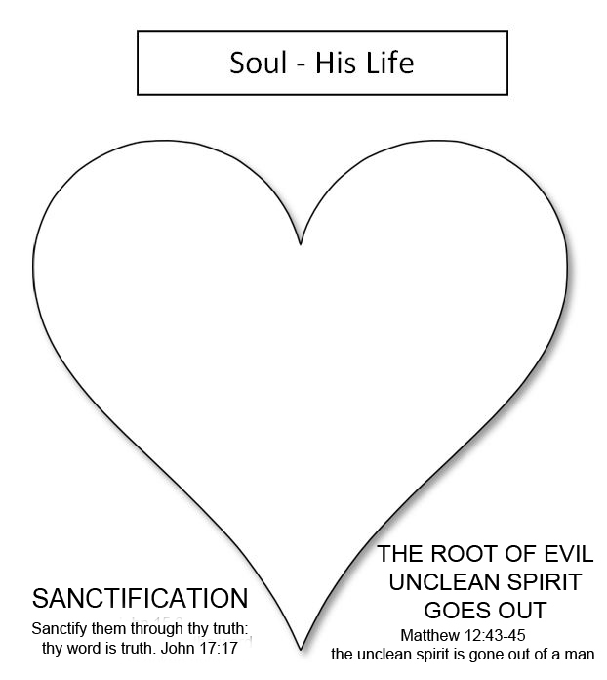

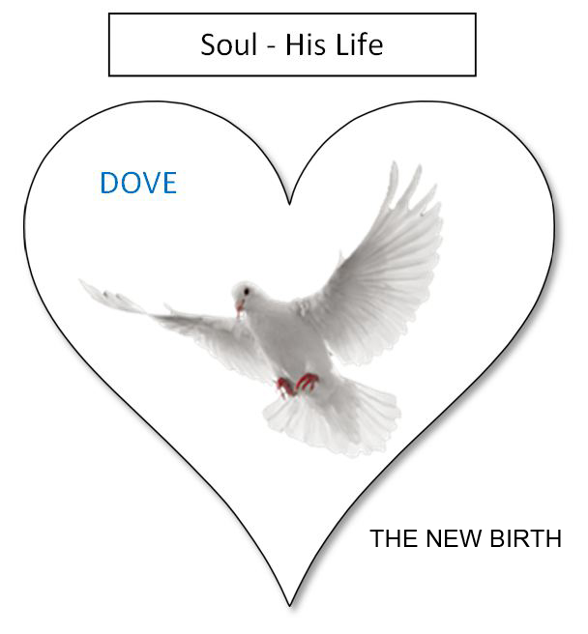

7) 65-0815 AND.KNOWETH.IT.NOT_ JEFFERSONVILLE.IN V-2 N-10 SUNDAY_
« 126 † And now the reason that people today... Now, don't forget this now, and you'll--you'll see what the Holy... what the initial evidence of the Holy Ghost is. See?
127 Now, people can live in this spirit, and they dance in the spirit. They shout in the spirit. They go to church in the spirit, and they can absolutely have the real Spirit of God anointed on that spirit, but still be lost and just as devil-possessed as they can be, with that spirit.
128 Because, watch, that's the reason you couldn't tell that woman, she was wearing shorts, was wrong. You couldn't tell her bobbing her hair was wrong. "Well, what's your hair got to do with it?" Well, it did to Samson. See?
129 "Whosoever shall add one word to This, or take one Word from It." You've got to have an ultimate somewhere.

8) 65-1126 WORKS.IS.FAITH.EXPRESSED_ SHREVEPORT.LA V-7 N-1 FRIDAY_
« 207 † Now, notice that, it's got to be. Five, f-a-i-t-h, outside; spirit, J-e-s-u-s; on the inside, y-o-u. See? That's how standing here, looking at you, I don't know a one of you. The spirit can anoint me, still I don't know none of you. But when that inside of the inside breaks in, that's God.
208 That's where the outside can reason. You take a man, say, "Well, you know, I--I know I'm not supposed to commit adultery. But, you know, then the spirit tells me I shouldn't commit adultery. But, you see, way down in there is still that thing in there." See, it'll kind of govern around, and better watch it.
209 But when it's directed from the inside, it throws all the rest of it together. That's the guidepost. That's the control tower, the inside of the inside. The soul controls the spirit, the spirit controls the body.
210 So an outside whitewash don't make any difference. Them religious people back there, that Paul called "whited-walls," and so forth, they were (outward) just every way the... a believer, and they had prophesies among them, and everything else but the inside of the inside ("the soul that disbelieveth").
211 That's the reason I say people can jump up and down, and speak in tongues, people can shout, lay hands on the sick, and heal the sick and so forth, by faith; all these great things there by the Spirit, still be lost. Anointed ones.

9) 65-0725M THE.ANOINTED.ONES.AT.THE.END.TIME_ JEFFERSONVILLE.IN V-5 N-3 SUNDAY_
« 26 † Now, it's a Sunday school lesson, we want to--to try to bring this to a real showdown, by the Scriptures, not by what someone else has said about it, but just reading the Scriptures.
You may say, "How can this be? Would the anointed ones..."
27 What were they? "Christs," C-h-r-i-s-t-s, anointed. "Christs, and false prophets." Anointed ones, but false prophets!
Jesus said, that, "The rain falls on the just and the unjust."
28 Now, someone might say to me, "Do you believe that that anointing on those people means that it's the anointing of the Holy Spirit?" Yes, sir, the genuine Holy Spirit of God upon a person, and yet they are false.
Now listen close and see what He said. "And they shall show signs and wonders, insomuch that it would deceive the very Elected if it were possible." And they are anointed with the genuine Holy Spirit. I know this sounds very foolish, but we're going to take time and explain it by the Word, that that's absolutely THUS SAITH THE LORD, the Truth.

