Notes used in the Message
www.SpokenWordChurch.com
19-0623am - Salvation Pt.14 (Stage 2) - Samuel Dale

EPHESIANS 2:8
» 8 † For by grace are ye saved through faith; and that not of yourselves: it is the gift of God:

ROMANS 3:23-26
» 23 † For all have sinned, and come short of the glory of God;
» 24 † Being justified freely by his grace through the redemption that is in Christ Jesus:
» 25 † Whom God hath set forth to be a propitiation through faith in his blood, to declare his righteousness for the remission of sins that are past, through the forbearance of God;
» 26 † To declare, I say, at this time his righteousness: that he might be just, and the justifier of him which believeth in Jesus.

1) 64-0802 THE.FUTURE.HOME.OF.THE.HEAVENLY.BRIDEGROOM.AND.THE.EARTHLY.BRIDE_ JEFFERSONVILLE.IN V-3 N-5 SUNDAY_
« 87 † Now, the first step is "repentance towards God." And then follows after that, is water baptism, "water baptism," "Repent, and be baptized in the Name of Jesus Christ." See, water baptism follows, showing that repentance was genuine. Or, to "remit" our past sins, that has nothing to do with future sin. It only remits. "Repent, and be baptized in the Name of Jesus Christ." What for? "Remission." Taking away of past sin has nothing to do with the future. Just, your sin has been chopped off, what you did.
88 You can't repent for what Adam done. You never done it; Adam did. You just get forgiveness for what you done. The old nature is still there.

1) 64-0802 THE.FUTURE.HOME.OF.THE.HEAVENLY.BRIDEGROOM.AND.THE.EARTHLY.BRIDE_ JEFFERSONVILLE.IN V-3 N-5 SUNDAY_
« 89 † Let me take this board just a minute. [Brother Branham draws illustrations on the blackboard--Ed.] Now, here is a human heart. Now, I'm not... I'm a long ways from being an artist. Here is a human heart; and here is a human heart. Now, this one over here has a snake in it, that's sin, here he has his life. This one over here has a dove in it, which is the Holy Spirit, here he has a Life. Well, this one here, he has malice, hatred, envy; that's what's causing it, is this fellow here. Well, this one over here has love, and joy, and long-suffering; and That's what does it, down here.
90 Now, when you are asked, or you are forgiven of your sins, you've only done this, taken that away. But the thing that made you do it is still there. That's the old root of evil; it's still there. Notice, then you repent and are baptized in the Name of Jesus Christ, that He forgave you of your sins. Notice.

« 91 † Then, secondly, comes sanctification, which sets our mind in order for holiness, to think right. Taken away... sanctification is a compound Greek word, which means "cleaned, and set aside for service."
92 Then, the next, comes the baptism of the Fire and Holy Ghost, that God might dwell in us. And the Fire of God cleanses our hearts from sin, and puts the Holy Ghost inside. Then we bring forth the same Life that This did, because That's in us.

2) 64-0802 THE.FUTURE.HOME.OF.THE.HEAVENLY.BRIDEGROOM.AND.THE.EARTHLY.BRIDE_ JEFFERSONVILLE.IN V-3 N-5 SUNDAY_
« 95 † Now notice, sanctification, the third stage... second stage of it, cleanses the mind; sets the heart, the mind of the heart, in order of holiness.
96 A man can repent of sins and he is still thinking of... Well, maybe he's a--a immoral man, every immoral looking woman he finds, is still there. Maybe he's a drunkard; every time he smells the drink, it's still there. See?
97 But then when he gets sanctified, that cleanses that desire out of him. See? It takes the want of it away. He can still be tempted, but He takes the want of it away. Still, he's not right yet.
98 Then, he is baptized with the Holy Ghost and Fire. Cleansed, burnt out, cleaned up; and then put into the service of God.
Sanctification only sets them aside for service.

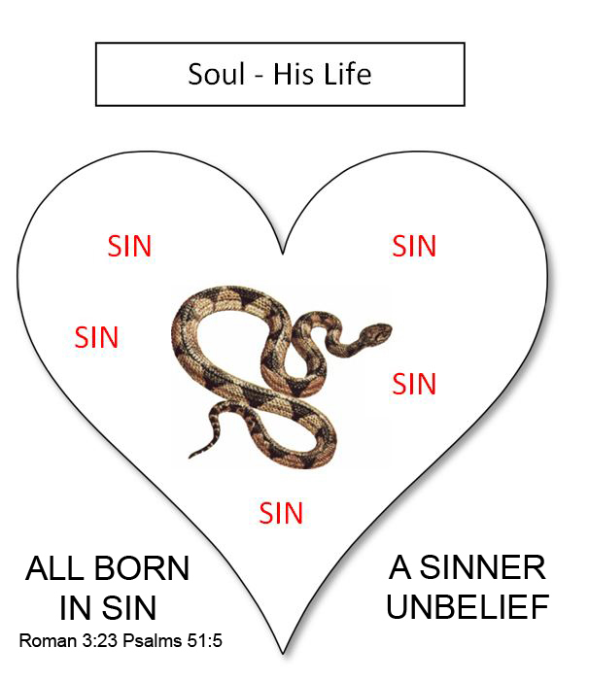

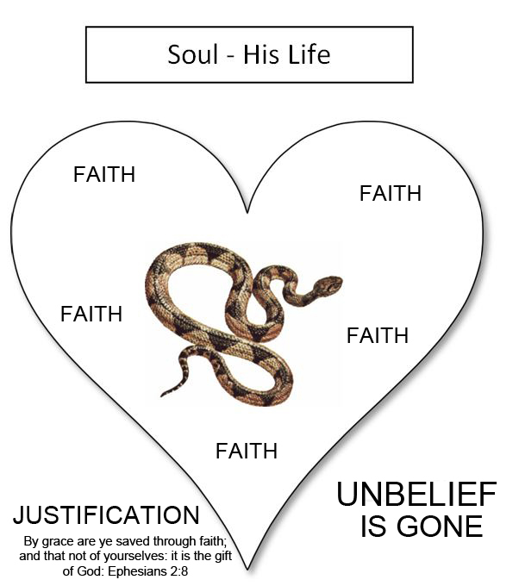

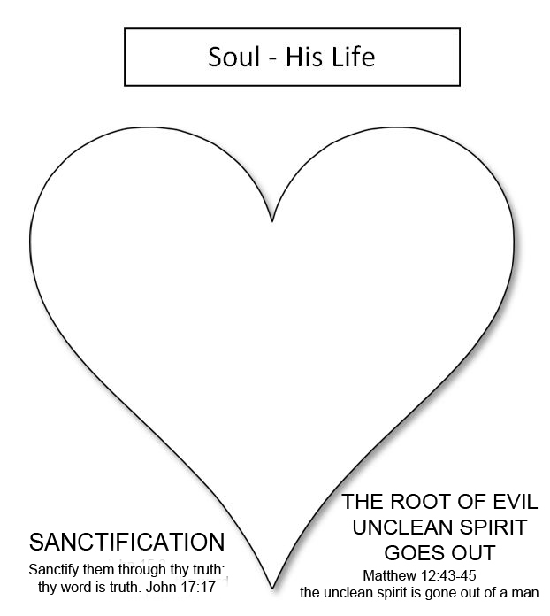

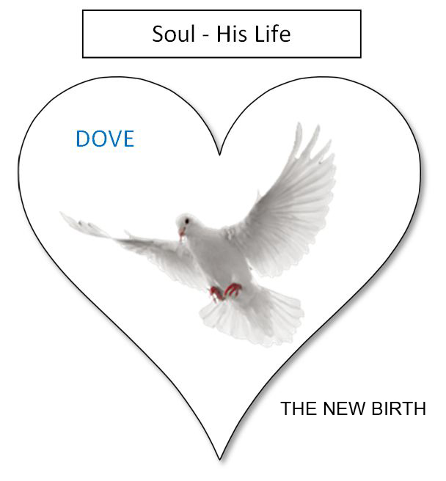

7) 65-0815 AND.KNOWETH.IT.NOT_ JEFFERSONVILLE.IN V-2 N-10 SUNDAY_
« 126 † And now the reason that people today... Now, don't forget this now, and you'll--you'll see what the Holy... what the initial evidence of the Holy Ghost is. See?
127 Now, people can live in this spirit, and they dance in the spirit. They shout in the spirit. They go to church in the spirit, and they can absolutely have the real Spirit of God anointed on that spirit, but still be lost and just as devil-possessed as they can be, with that spirit.
128 Because, watch, that's the reason you couldn't tell that woman, she was wearing shorts, was wrong. You couldn't tell her bobbing her hair was wrong. "Well, what's your hair got to do with it?" Well, it did to Samson. See?
129 "Whosoever shall add one word to This, or take one Word from It." You've got to have an ultimate somewhere.

8) 65-1126 WORKS.IS.FAITH.EXPRESSED_ SHREVEPORT.LA V-7 N-1 FRIDAY_
« 207 † Now, notice that, it's got to be. Five, f-a-i-t-h, outside; spirit, J-e-s-u-s; on the inside, y-o-u. See? That's how standing here, looking at you, I don't know a one of you. The spirit can anoint me, still I don't know none of you. But when that inside of the inside breaks in, that's God.
208 That's where the outside can reason. You take a man, say, "Well, you know, I--I know I'm not supposed to commit adultery. But, you know, then the spirit tells me I shouldn't commit adultery. But, you see, way down in there is still that thing in there." See, it'll kind of govern around, and better watch it.
209 But when it's directed from the inside, it throws all the rest of it together. That's the guidepost. That's the control tower, the inside of the inside. The soul controls the spirit, the spirit controls the body.
210 So an outside whitewash don't make any difference. Them religious people back there, that Paul called "whited-walls," and so forth, they were (outward) just every way the... a believer, and they had prophesies among them, and everything else but the inside of the inside ("the soul that disbelieveth").
211 That's the reason I say people can jump up and down, and speak in tongues, people can shout, lay hands on the sick, and heal the sick and so forth, by faith; all these great things there by the Spirit, still be lost. Anointed ones.

9) 65-0725M THE.ANOINTED.ONES.AT.THE.END.TIME_ JEFFERSONVILLE.IN V-5 N-3 SUNDAY_
« 26 † Now, it's a Sunday school lesson, we want to--to try to bring this to a real showdown, by the Scriptures, not by what someone else has said about it, but just reading the Scriptures.
You may say, "How can this be? Would the anointed ones..."
27 What were they? "Christs," C-h-r-i-s-t-s, anointed. "Christs, and false prophets." Anointed ones, but false prophets!
Jesus said, that, "The rain falls on the just and the unjust."
28 Now, someone might say to me, "Do you believe that that anointing on those people means that it's the anointing of the Holy Spirit?" Yes, sir, the genuine Holy Spirit of God upon a person, and yet they are false.
Now listen close and see what He said. "And they shall show signs and wonders, insomuch that it would deceive the very Elected if it were possible." And they are anointed with the genuine Holy Spirit. I know this sounds very foolish, but we're going to take time and explain it by the Word, that that's absolutely THUS SAITH THE LORD, the Truth.

