Notes used in the Message

www.SpokenWordChurch.com
19-0113am - At The Revelation Of Jesus Christ Pt.6 (Future Made Known) - Samuel Dale
I PETER 1:7-13
» 7 † That the trial of your faith, being much more precious than of gold that perisheth, though it be tried with fire, might be found unto praise and honour and glory at the appearing of Jesus Christ:
» 8 † Whom having not seen, ye love; in whom, though now ye see him not, yet believing, ye rejoice with joy unspeakable and full of glory:
» 9 † Receiving the end of your faith, even the salvation of your souls.
» 10 † ¶ Of which salvation the prophets have enquired and searched diligently, who prophesied of the grace that should come unto you:
» 11 † Searching what, or what manner of time the Spirit of Christ which was in them did signify, when it testified beforehand the sufferings of Christ, and the glory that should follow.
» 12 † Unto whom it was revealed, that not unto themselves, but unto us they did minister the things, which are now reported unto you by them that have preached the gospel unto you with the Holy Ghost sent down from heaven; which things the angels desire to look into.
» 13 † ¶ Wherefore gird up the loins of your mind, be sober, and hope to the end for the grace that is to be brought unto you at the revelation of Jesus Christ;

REVELATION 1:1-3
» 1 † ¶ The Revelation of Jesus Christ, which God gave unto him, to shew unto his servants things which must shortly come to pass; and he sent and signified it by his angel unto his servant John:
» 2 † Who bare record of the word of God, and of the testimony of Jesus Christ, and of all things that he saw.
» 3 † ¶ Blessed is he that readeth, and they that hear the words of this prophecy, and keep those things which are written therein: for the time is at hand.

1) 54-0512 THE.SEVEN.CHURCH.AGES_ JEFFERSONVILLE.IN V-26 N-2 WEDNESDAY_
« 204 † Now, that's the Bible. That's what the Spirit said. See? The candlesticks... All right. Now, the 13th verse.
And in the midst of the seven golden candlesticks one like the Son of man...
What? One like Him. Who was this? His Bride. One like Him, watch how it was.
... clothed with a garment down to the foot...
The holiness of Jesus Christ covering Her. Has washed us from our sins, with His Own Blood. All right.
... girded about the paps... (not a man; a woman)... with a golden girdle... (The Gospel that held the power and glory of God over the Body of Christ.)
Oh, what a beautiful picture we got here under consideration. Looky here.
... down to the foot, and a gird about the paps with a golden girdle.
His head and his hair was white as wool... white as snow... (Righteousness, holiness, white speaks of...); and his eyes like flames of fire; (Looks right through us.)
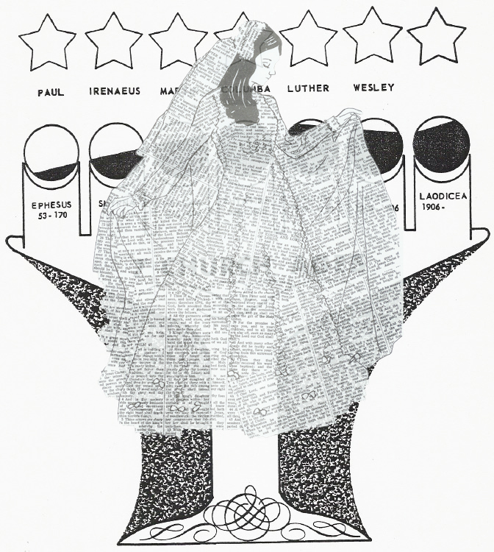

2) 58-0927 WHY.ARE.WE.NOT.A.DENOMINATION_ JEFFERSONVILLE.IN V-11 N-7 SATURDAY_
« 180 † Now, if you ever notice, watch these church ages; then we'll close. And then in the morning we're going to pick up these other things. Watch. In the... Under the--the golden candlesticks of the Jewish tabernacle in the inside, of the shewbread and so forth, there was seven golden candlesticks. All of you know that. See? There's seven church ages. That speaks of seven church ages alike.
Now if you notice in Revelations 1, we find Jesus standing in the seven church ages, the seven golden candlesticks, when he turned and saw One like the Son of man standing clothed with a... How it was, it was a Bride standing in the candlesticks drawed out.
Now, in the Old Testament, they would take these, this one candle and light it, take the other candle and light off of that one, light off of that one, one off the other one like that, till they made the entire seven candlesticks.

3) 62-0909E IN.HIS.PRESENCE_ JEFFERSONVILLE.IN V-11 N-4 SUNDAY_
« 26 † What about the great Saint John of Revelations 1:7, when he was showed the vision, and looked, and heard a Voice speaking to him. And he turned to look to see the Voice, and he saw seven golden candlesticks. And One stood in the midst of the seven golden candlesticks, with hair like wool, eyes like flames of fire, feet like pillars of brass, He was girded with a golden girdle around the paps, and He was called the Word of God. And when the great Saint John had walked with Christ, leaned upon His bosom, when he done all these things! As I said this morning, Paul's ministry exceeded any of them. Here, after John had walked with Jesus, talked with Him, slept with Him, eat with Him, but when he seen Him standing there, that glorified state, he said he fell like a dead man at His feet. Amen. Think of it!

4) « 49-4 † PATMOS.VISION - CHURCH.AGE.BOOK CPT.2
Revelation 1:12,
"And I turned to see the voice that spake with me. And being turned, I saw seven golden candlesticks."
John does not say that he turned to see the one whose voice he heard, but he turned to see the voice. Oh, I like that. He turned to see the voice. The voice and the person are one and the same. Jesus is the WORD.
John 1:1-3,
"In the beginning was the Word, and the Word was with God, and the Word was God.
The Same was in the beginning with God.
All things were made by Him; and without Him was not any thing made that was made."
If you can ever get to really see the Word you will be seeing Jesus.

5) « 12-2 † THE.REVELATION.OF.JESUS.CHRIST - CHURCH.AGE.BOOK CPT.1
The scribe (not author) of this book is St. John the divine. Historians agree that he lived the last part of his life in Ephesus, though at the time of the writing of this book he was on the Isle of Patmos. It is not the life story of John, but it is the Revelation of Jesus Christ in the future church ages. In verse three it is called a prophecy and that is actually what it is.

6) 60-1204M THE.REVELATION.OF.JESUS.CHRIST_ JEFFERSONVILLE.IN ROJC 9-67 SUNDAY_
« 70 † Historians agree, this is John's life. John lived the last of his years in the city of Ephesus and died there. He was on the isle of Patmos, at the time he wrote the Book, Revelation. It was not the story of his life, but the story of Christ in future ages. See? It was a prophecy. Not the life of John, not the life of Christ, but prophesying of an age to come. It was not his prophetic utterances; but, the Lord's exaltations, solemnly. It was not the Revelation of Saint John the divine, but the Revelation of Christ the Lord.
It is the last Book of the New Testament, yet it tells the beginning and the end of the dispensation of the Gospel. Got Bible scholars agreeing.
The letters to the seven church ages were written, prophetically, to the future ages. Paul wrote of the life and glory of the seven churches present in his day. John wrote of the life and glory of the seven churches in the future, that John was addressing the seven pastors or messengers as directly all Christians under these seven different angels.

7) « 13-1 † THE.REVELATION.OF.JESUS.CHRIST - CHURCH.AGE.BOOK CPT.1
This book is usually termed the Revelation of Saint John, but that is incorrect. It is the Revelation of Jesus Christ given to John for Christians of all ages. It is the only book in the entire Bible that is written by Jesus Himself, through personally appearing to a scribe.

« 13-2 † It is the last book of the Bible, yet it tells the beginning and the end of the dispensations of the Gospel.

« 13-3 † Now the Greek word for revelation is "apocalypse" which means "unveiling". This unveiling is perfectly described in the example of a sculptor unveiling his work of statuary, exposing it to the onlooker. It is an uncovering, revealing what was previously hidden. Now the uncovering is not only the revelation of the Person of Christ, but it is THE REVELATION OF HIS FUTURE WORKS IN THE ONCOMING SEVEN CHURCH AGES.

8) 60-1205 THE.EPHESIAN.CHURCH.AGE_ JEFFERSONVILLE.IN ROJC 131-183 MONDAY_
« 30 † Now, then the Bible reveals Him here, that He is the Almighty God, flesh among us. See? No Father, Son, and Holy Ghost; it's not three gods, or one God chopped in three places. It's one God that worked in three offices: the Fatherhood, Sonship, and the Holy Ghost. God condescending from the garden of Eden, trying to make His way back into human hearts, to live and be sons and daughters of God again with Him. That's God above us, God with us, God in us. That's the difference. See?
And now those things, and the Bible reveals that and has thoroughly said it in the 1st chapter of Revelation; which is the only Book in the Bible, in the New Testament, the whole canon of the New Testament, is the only Book that Jesus put His own seal upon. And He said, the first of It, "Blessed is he that readeth and he that heareth." And at the end, He said, "If any man shall take away any part of It, or add anything to It, the same will be taken, his part, out of the Book of Life." So it's a curse for anyone to take anything away, this is the complete Revelation of Jesus Christ. So if we make Him three, you know what's happened. See, your name goes out.

9) 60-1204M THE.REVELATION.OF.JESUS.CHRIST_ JEFFERSONVILLE.IN ROJC 9-67 SUNDAY_
« 76 † Now, the title describes the character.
The Revelation of Jesus Christ,...
Not the revelation of Saint John the divine, but the Revelation of Jesus Christ, the Son of God.
Now, the Greek word for revelation is the apocalypse, which means "the unfolding." And I was taking that word and searching it. It means, the apocalypse, is to... Like a sculptor, has made a great statue, and he's got it covered by a veil. And then he goes and tears back this veil and reveals what he has behind the veil. It's an uncovering.
And this Book is not the uncovering of, so much, the Person of Jesus Christ. Yet, it certainly speaks of His Deity and His sevenfold personage, and also of the things that He is, like Priest, King, and so forth. But it is the revealing of the future of His works in His seven church ages that's coming on. It...

« 80 † When our Lord was on earth, the disciples asked Him, and said, "Master, will you at this time restore the kingdom back to Israel?"
And Jesus said, "It's not for you to know this hour or time." And no one would know. Said, "Even the Son," as yet, "did not know."
But after His death, burial, and resurrection, and ascension into Glory, He received from God the future of the Church. Then He returned back, to bring this Message to the Church, and this Message of His coming and the condition of His churches down through the Age.
He could not do it before His death, burial, and resurrection, because He had not yet knew it. But did you notice how the Scripture reads here?
The Revelation of Jesus Christ, which God gave unto him (Christ),...
How that God the Father gave the Revelation to His Son Jesus Christ. And He sent His angel to John, to signify these things which was; which was, which is, and which shall be. Oh, it's set beautifully!

« 85 † Now, in this great coming age that John saw! Now, these, this Revelation was given to him, strictly, to unveil the specific purpose of Christ, what He would be and be like, in every age. That's the reason I said, this morning, keep your mind on the true Church. The true Church began on the Day of Pentecost.
There's no theologian, Bible scholar, or historian, can ever say that it began in the days of Martin Luther, Wesley, Catholic age, or any other age. It began at Pentecost. That was the inauguration of the Church. That was the beginning. So, therefore, in a discussion with anybody, stand at that gate of Pentecost, and they cannot go nowhere else.

